
Dear students of class 9/3! 18th March 2020

How are you? Are you having any problems with online classroom? If yes, please drop a line at alenka.kavka@os-preserjeradomlje.si, or ask me in the chatroom or forum.
How was the interactive practice on passive? Have you checked the results?
How’s your progress on the presentation?
Your task for today is as follows:
- Practice Conditional clauses (you'll find link(s) in the online classroom)
- Start preparing your PPT or poster.

Dear students, keep up the good work! You’re awesome.
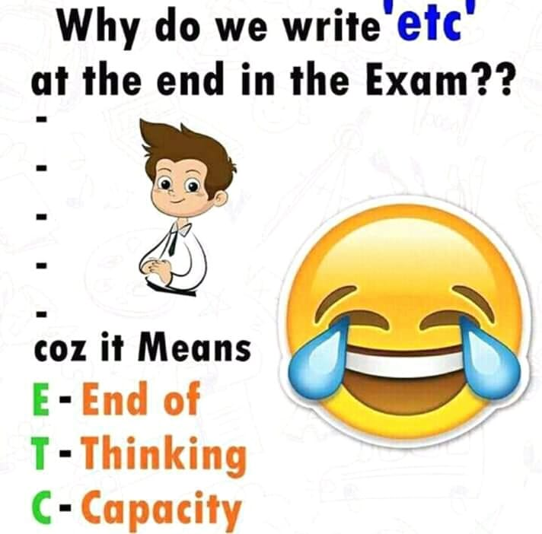
Your teacher Alenka
P. S. Joke of the day …

Dragi učenci, ker ste že zelo vešči angleščine, so navodila v ciljnem jeziku. Se pa vsakemu kdaj zgodi, da se kje zatakne, zato prosim brez skrbi vprašajte, če je kaj nejasnega. Srečno!

