PREBERI.
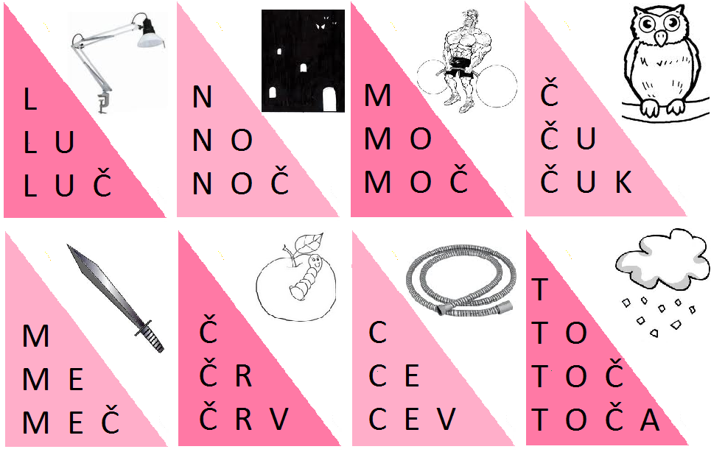

DEJAN IMA OČALA.
DEČEK JE ULOVIL 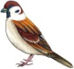.
V KOČIJI SE PELJETA 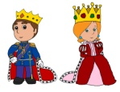.
PREPIŠI.
RAD JEM ČOKOLADNE PALAČINKE.
___________________________________________________________________________________ _ _ _ _ _ _ _ _ _ _ _ _ _ _ _ _ _ _ _ _ _ _ _ _ _ _ _ _ _ _ _ _ _ _ _ _ _ _ _ _ _ _ _ _ _ _ _ _ _ _ _ _ _ _ _ __________________________________________________________________________________
___________________________________________________________________________________ _ _ _ _ _ _ _ _ _ _ _ _ _ _ _ _ _ _ _ _ _ _ _ _ _ _ _ _ _ _ _ _ _ _ _ _ _ _ _ _ _ _ _ _ _ _ _ _ _ _ _ _ _ _ _ __________________________________________________________________________________
___________________________________________________________________________________ _ _ _ _ _ _ _ _ _ _ _ _ _ _ _ _ _ _ _ _ _ _ _ _ _ _ _ _ _ _ _ _ _ _ _ _ _ _ _ _ _ _ _ _ _ _ _ _ _ _ _ _ _ _ _ __________________________________________________________________________________

