
Dear students of class 9/3! 19th March 2020

How are you? I hope you’ve all got used to the online classroom. If there are any questions, please drop a line at alenka.kavka@os-preserjeradomlje.si, or ask me in the chatroom or forum.
How was the interactive practice on conditional clauses? Have you checked the results?
How’s your progress on the presentation?
Your task for today is as follows:
- Practice Word formation (you'll find link(s) in the online classroom)
- Continue preparing your PPT or poster. By now you should have all the content. Now you can start thinking about visual support (search for pictures, videos, …). Next time you will proof read your text to see if there are any mistakes to correct.

Dear students, keep up the good work and stay healthy .
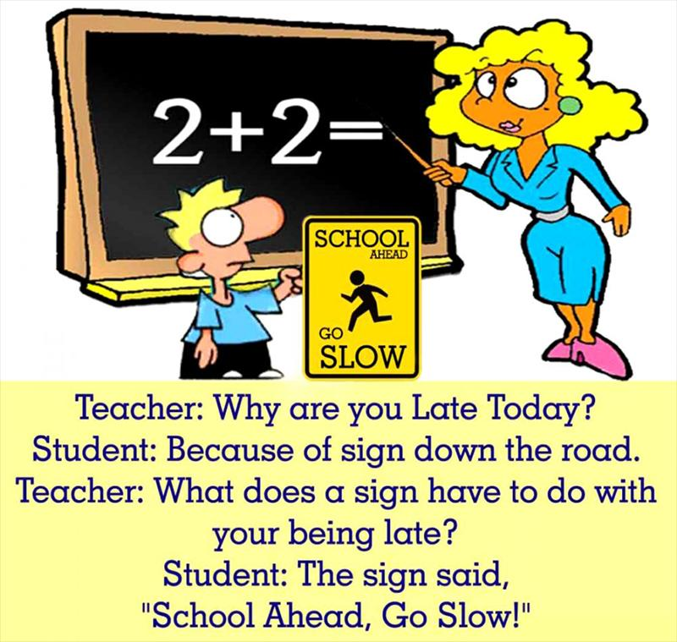
Your teacher Alenka
P. S. Joke of the day …

Dragi učenci, ker ste že zelo vešči angleščine, so navodila v ciljnem jeziku. Se pa vsakemu kdaj zgodi, da se kje zatakne, zato prosim brez skrbi vprašajte, če je kaj nejasnega. Srečno!

