WHAT’S THE TIME ? [= Koliko je ura?]
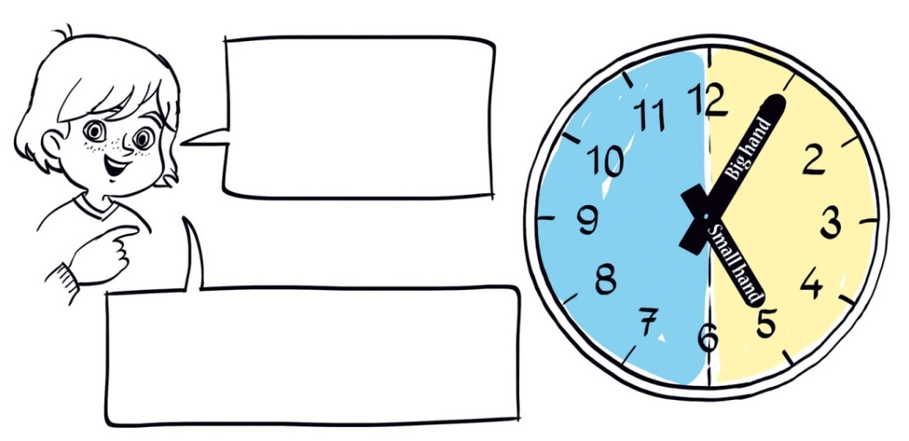
WHAT'S THE TIME? WHAT TIME IS …? WHEN …?
USE 'PAST' FOR 1-30 MINUTES AND 'TO' FOR 31-59 MINUTES.
BIG HAND | SMALL HAND |  | What's the time?
1 = five past | 1 = one |  | 1 11:30 It's half past eleven.
2 = ten past | 2 = two |  | 2 12:00 ____________________
3 = a quarter past | 3 = three |  | 3 01:10 ____________________
4 = twenty past | 4 = four |  | 4 04:40 ____________________
5 = twenty-five past | 5 = five |  | 5 02:15 ____________________
6 = half past | 6 = six |  | 6 08:00 ____________________
7 = twenty-five to | 7 = seven |  | 7 08:55 ____________________
8 = twenty to | 8 = eight |  | 8 05:30 ____________________
9 = a quarter to | 9 = nine |  | 9 06:45 ____________________
10 = ten to | 10 = ten |  | 10 10:05 ___________________
11 = five to | 11 = eleven |  | 11 03:20 ___________________
12 = o'clock | 12 = twelve |  | 12 05:35 ___________________

