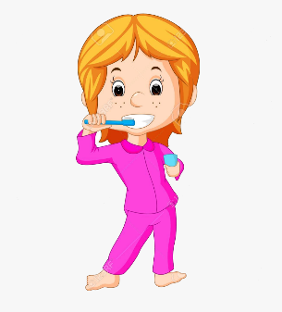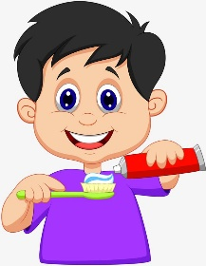

You MUST brush your teeth before going to bed.

Pred spanjem si MORAŠ umiti zobe.

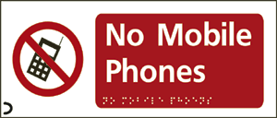

You MUSTN'T use your mobile phone in school.

V šoli NE SMEŠ uporabljati mobilnega telefona.

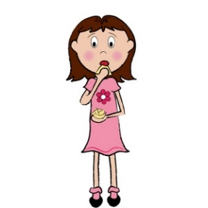
She CAN dance. She CAN'T dance.

ZNA plesati. NE ZNA plesati.

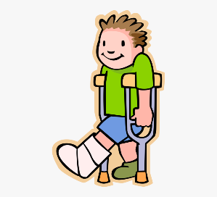 He CAN'T play football. NE MORE igrati nogometa.

