1x bon za pomivanje posode 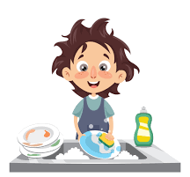

1x bon za sesanje stanovanja 

1x bon za čiščenje čevljev 

1x bon za nošnjo smeti v smetnjak 

1x bon za zalivanje rož 

1x bon za postiljanje postelj 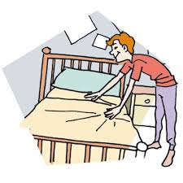

NAVODILA ZA IZDELAVO:
BONE PRILEPITE NA TRD KARTON, JIH IZREŽITE IN JIH POKLONITE SVOJIM MAMAM.
Lahko dodate tudi svoj bon z dejavnostjo, ki jo boste v prihodnosti pripravljeni postoriti za svoje mame.
Slikovni viri:
- https://www.google.com/search?q=washing+dishes+cartoon&safe=active&sxsrf=ALeKk0088ze2HbzqkGiM_vlOPukNx62o6Q:1584997876952&source=lnms&tbm=isch&sa=X&ved=2ahUKEwiErLObwbHoAhUwpIsKHYIlDokQ_AUoAXoECAsQAw&biw=1920&bih=941, dne 23.3.2020
- https://www.google.com/search?q=hoover+apartment+cartoon&tbm=isch&ved=2ahUKEwjcuc2iwbHoAhVJzaQKHULzDHgQ2cCegQIABAA&oq=hoover+apartment+cartoon&gs_l=img.3...472131.590605..591106...25.0..0.406.4970.9j14j5j2j1......0....1..gwsimg.......0i19j0i7i30i19j0i7i30j0j0i67j0i7i5i30j0i8i7i30.-_30_AtiH90&ei=BCZ5XtynA8makwXC5rPABw&bih=941&biw=1920&safe=active, dne 23.3.2020
- https://www.google.com/search?q=cleaning+shoes+cartoon&safe=active&sxsrf=ALeKk01ckji_rP0vDVVmwxTUCo-KvwHDZQ:1584998889274&source=lnms&tbm=isch&sa=X&ved=2ahUKEwjato7-xLHoAhWOxIsKHdRpAmQQ_AUoAXoECAsQAw&biw=1920&bih=941, dne 23.3.2020
- https://www.google.com/search?q=to+throw+waste+in+a+garbage+can+cartoon&tbm=isch&ved=2ahUKEwin8d39xrHoAhXIt6QKHVyVC4UQ2-cCegQIABAA&oq=to+throw+waste+in+a+garbage+can+cartoon&gs_l=img.3...12161.24380..26173...0.0..1.464.3058.11j5j2j0j2......0....1..gws-wiz-img.......0i8i7i30j0i8i30.frQ04-GNdTI&ei=ASx5XufsFMjvkgXcqq6oCA&bih=941&biw=1920&safe=active, dne 23.3.2020
- https://www.google.com/search?q=make+beds+cartoon&tbm=isch&ved=2ahUKEwjnj_OvyLHoAhWS76QKHd-sB9gQ2-cCegQIABAA&oq=make+beds+cartoon&gs_l=img.12..0i19.214179.223961..225927...0.0..0.200.1351.2j8j1......0....1..gws-wiz-img.......0i7i30i19j0i7i30j0i7i5i30j0i8i7i30j0i5i30i19.yDUUa1HPrcs&ei=di15Xuf8O5LfkwXf2Z7ADQ&bih=941&biw=1920&safe=active, dne 23.3.2020

