OŠ Spodnja Šiška DELO NA DOMU | Datum: TOREK, 31.3.2020
Razred: 5.B  Učna ura: 7 | Učna snov: Utrjevanje: Town buildings; There is / are; pridevniki; How do you go to school?
Učitelj: Lori Podgornik

Ponovitev učne snovi (unit 4 and 5)
1. Utrdi besedišče in predloge in naredi vajo 1 delovnem zvezku na strani 40. Rešitve najdeš na koncu učnih listov ali v 5.uri, 25.3.
2x klik na mali pravokotniček, ki ima v sredini rdeče črno piko (ikonco), takoj pod to vrstico, in nato klik na Odpri. Nato POČAKAJ!

2. Sledeče povedi prepiši v zvezek, tako da jih dopolniš z THERE IS / THERE ARE.
Ne pozabi: THERE IS + A / AN + EDNINA
THERE ARE + MNOŽINA

- ___________________ two parrots.
- ___________________ a lion.
- ___________________ three turtles.
- ___________________ a hippo.
- ___________________ a mouse.
- ___________________ two rabbits.
- ___________________ a cat.
3. Utrdi uporabo predlogov in sledeče povedi prepiši v zvezek, tako da jih dopolniš z BETWEEN, NEXT TO, OPPOSITE, BEHIND, IN FRONT OF. (več možnih rešitev)
Where is the………? (Kje je…?)

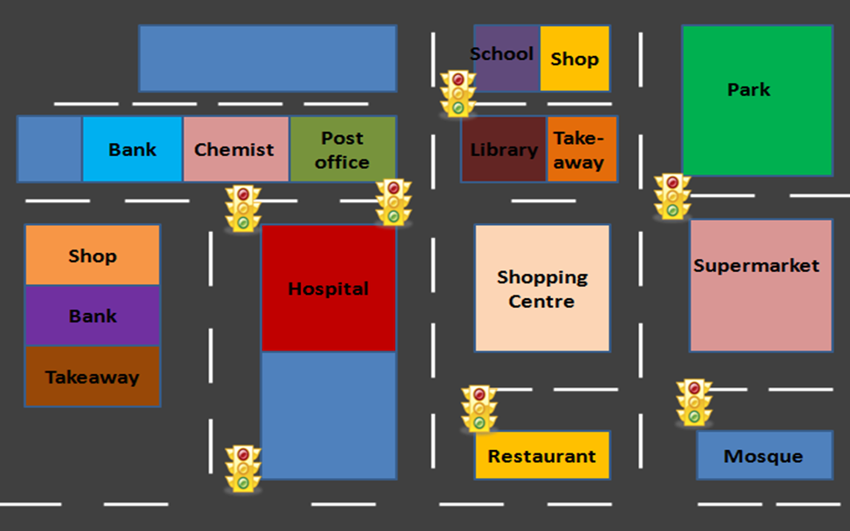

- The shop is _____________________ the school.
- The takeaway is _____________________ the library.
- The chemist is _____________________ the bank and the post office.
- The hospital is _____________________ the shopping centre.
- The bank is _____________________ the shop and the takeaway.
- The restaurant is _____________________ the shopping centre.

4. HOW DO YOU GO TO SCHOOL? (KAKO GREŠ V ŠOLO). Napiši kako greš TI v šolo. Napiši v zvezek.
Primer:
I go to school by bus.
- 1. _________________________________
- 2. ________________________________
- 3. _________________________________
- 4. 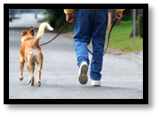________________________________

5. Prepiši v zvezek in dopolni povedi s pridevniki. (več možnih rešitev)
Sad – Big – Fat – Small – Happy - Thin

 The fish is _____________

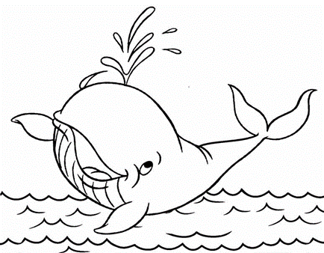 The whale is ___________

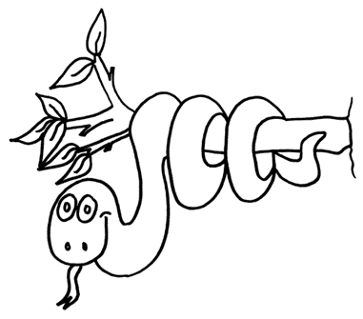 The snake is ___________
 The pig is _____________
 The dog is _____________
 The frog is ____________

1.REŠITVE: dz,str. 40/ 1: (so že v 5.uri, 25.3), za vsak slučaj, še enkrat:
supermarket library toy shop restaurant
church cinema cafe station
2. dz,str. 42/ 1 (5.ura, 25.3.20)
Emily: by car/bus James: He walks. Rosie: by bus/bike
3. Učna ura 5: (sreda, 25.3.2020)
1. _restaurant ___ 2 school___ 3. fire station ___
4. post office ___ 5. bookshop _ 6. building
7. 9. shopping centre/ supermarket 8. zoo
10. video arcade _
- There is a big zoo in town. T
- There isn’t a school in this town. F
- There are two schools in this town. F
- There are a lot of cars in this town. F
- There aren’t two restaurants in this town. T
- There is a video arcade in this town. T

- There is a tall building in this town.T
- There is a church in this town. F
- There isn’t a fire station in this town.F
- There aren’t two shopping centres in this town. T

