EASTER

The rabbits are getting ready for Easter! Can you find a baby chicken?
(Ali najdeš piščančka med zajci?)
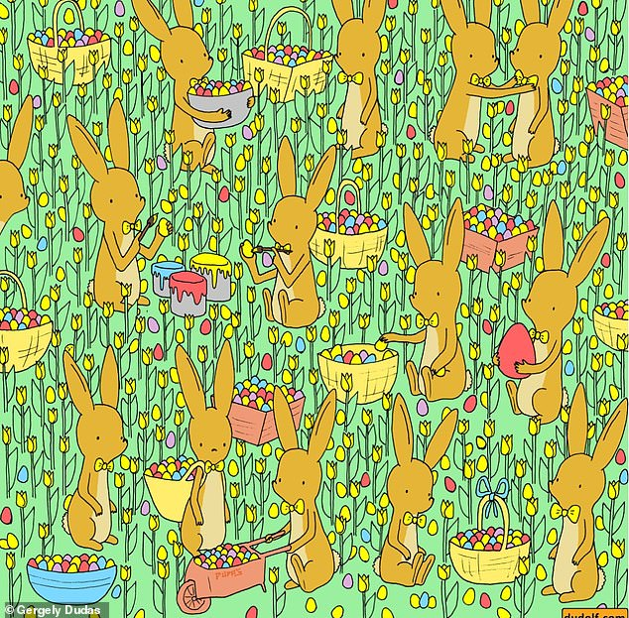

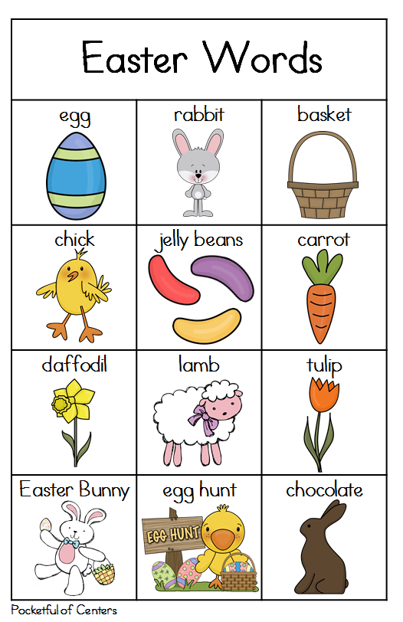

Find 10 Differences (poišči 10 razlik med slikama):
http://www.akidsheart.com/holidays/easter/ojs9/easterdiff1.html

