30. 3. 2020 | TJA – 6. razred | Grammar and Vocabulary Revision; 2 uri  Writing a Holiday Postcard

Dear pupil,

We are starting the third week of distance education. I hope you study the material and do the tasks regularly. If there is a problem, please, contact me immediately and I will be happy to help you resolve the question at hand.

I wish you all the best. Stay safe and sound.

Your English teacher

Dejavnosti so označene z različnimi barvami. Oglej si spodnjo legendo, ki ti razloži rabo barv. Tebi je prepuščeno, kolikšno količino nalog boš opravil/-a. Čeprav se modra in vijolična nanašata na zelo uspešne učence, to ne pomeni, da ne smeš narediti tovrstnih dejavnosti – če želiš, lahko.

Legenda:
temno modra – rešitve nalog prejšnje ure (morajo pregledati vsi učenci)
črna – naloge morajo narediti vsi; minimalna zahtevnost
zelena – naloge naredijo tisti, ki so pri pouku srednje uspešni
modra – naloge naredijo tisti, ki so pri pouku zelo uspešni
vijolična – dodatne naloge; če si želiš več utrjevanja ali ko ti je dolgčas

1. ura

Before we move on, we need to check the exercises you did on Thursday. Here are the answers.
Preden nadaljujemo, moramo pregledati naloge, ki si jih naredil v četrtek. Tu so odgovori.

WB p. 120/ ex. 33
2 It's rainy and warm. 6 It's sunny and very hot.
3 It's cloudy and cold. / warm. 7 It's warm and sunny.
4 It's hot and sunny. 8 It's sunny and very hot.
WB = workbook (del. zvezek)
SB = student's book (učb.)
p. = page (str.)
ex. = exercise (nal.)
5 It's warm and windy.

WB p. 120/ ex. 34
Today is 26th March 2020. It is cold and windy. At times it is snowy.

SB p. 127/ ex. 6a
1 F / T 4 F 7 F 10 F opomba k 1: mišljene so poletne počitnice,
2 T 5 F 8 T 11 T vendar imamo tudi jesenske
3 T 6 T 9 T 12T
SB p. 128/ ex. 9
4 now 8 now
5 now 9 always/ every day
6 every week 10 always/ never
7 always/ every day

Let's revise the vocabulary of Monday’s lesson first.
Before you start the exercise, put down the title Exercise in your notebook. Then open your SB on page 126. You are going to do exercise 2. First, take a look at the given example – it is in the yellow box on the left side of the exercise.
Choose 4 pictures and write down a dialogue for each.
Choose 7 pictures and write down a dialogue for each.
Look at all the pictures and write down a dialogue for each.

Najprej ponovimo besedišče ponedeljkove ure.
Preden začneš nalogo, v svoj zvezek zapiši naslov Exercise. Sedaj odpri učbenik na str. 126. Naredil boš nal. 2. Najprej si poglej primer v rumenem okvirju na levi strani naloge.
Izberi 4 sličice in za vsako napiši en dialog.
Izberi 7 sličic in za vsako napiši en dialog.
Oglej si vse sličice in za vsako napiši en dialog.

Now do ex. 4 on p. 127 in your student's book. Copy the link in your browser and listen to the tape (twice if you have to). Tick the expressions that you hear in the dialogue.
http://e-gradiva.com/dokumenti/T6/eT6/T6-4_datoteke/A156.webm
Sedaj naredi nal. 4 na str. 127 v učbeniku. Kopiraj dano povezavo v spletni brskalnik in poslušaj posnetek (dvakrat, če je potrebno). Obkljukaj izraze, ki jih slišiš v pogovoru.
http://e-gradiva.com/dokumenti/T6/eT6/T6-4_datoteke/A156.webm

Take a look at the given picture in the box below. Write as many the sentences as you can in 5 minutes in your notebook. You don’t need a new title; just continue under the Exercise where you left off. Take a look at the given example – the first sentence is already done for you.
Sedaj si oglej spodnjo sliko v okvirju. V zvezek napiši čim več stavkov v 5 minutah. Ne potrebuješ novega naslova, nadaljuj pod Exercise, kjer si končal. Oglej si dani primer – prvi stavek je že narejen.

How many sentences can you write?

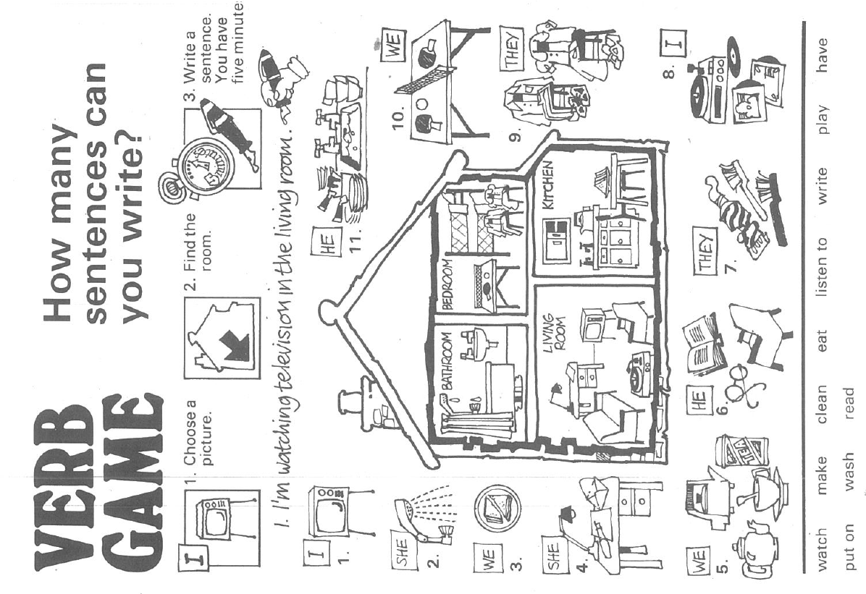

So, how did you do? Did you manage to write the 10 remaining sentences in 5 minutes?
If you put down at least 7 sentences, you did quite well.
No, kako ti je šlo? Si uspel/-a napisati preostalih 10 stavkov v 5 minutah?
Če si napisal/-a vsaj 7 stavkov, ti je šlo kar dobro.

2. ura

To start the second part of today's lesson, grab your workbook, open it on p. 119 and do ex. 32.
Za začetek današnje druge ure, vzemi delovni zvezek, ga odpri na str. 119 in naredi nal. 32.

Now answer the questions below. You don't have to write anything down.
Odgovori na spodnja vprašanja. Ničesar ti ni treba zapisati.

- Do you like writing postcards? Why (not)?
- Who do you usually write to?
- What do you write about?

Copy the text below into your notebook.
Spodnjo snov zapiši v zvezek.

________________________________________________________________________________

Writing a Holiday Postcard

___date___  Dear_________________,  Where are you?  What's it like there? Describe the place.  What can you see? What is going on?  What's the weather like?  What's the food like?  What can you do there?  What are you doing at the moment?  I miss you. / I wish you were here.  Love, / Greetings, / Best wishes, / See you soon,  ____sign your name_________ | 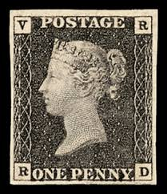  ______________________________  ______________________________  ______________________________  ______________________________

________________________________________________________________________________

The Blacks:
Imagine you are on holidays. Try writing a postcard to your friend or relative. First, take a look at the four postcard in your SB on p. 125, ex. 1b. They can serve as an example. Of course, you can use the cues from »the postcard« above.
Predstavljaj si, da si na počitnicah. Poskusi napisati razglednico svojemu prijatelju ali sorodniku. Najprej si oglej štiri razglednice v učb. na str. 125, nal. 1b. Uporabi jih za zgled. Seveda lahko upoabiš tudi iztočnice iz »razglednice« zgoraj.

The Greens and the Blues:
Imagine you are on holidays. Write a postcard. Decide who you are writing to and answer the questions (not necessarily in that order) from »the postcard« above to write the text. Poleg danih iztočnic lahko uporabiš tudi svoje ideje.
Predstavljaj si, da si na počitnicah. Napiši razglednico. Odloči se, komu pišeš, in odgovori na vprašanja (ni nujno, da v tem vrstnem redu) iz »razglednice« zgoraj, da napišeš besedilo. Poleg danih iztočnic lahko uporabiš tudi svoje ideje.

EXTRA or WHEN BORED:
Weather – scrambled letters (pomešane črke)
https://www.englisch-hilfen.de/en/exercises/environment/weather.htm
Weather – quiz
https://www.englishexercises.org/makeagame/viewgame.asp?id=1526#a
Present Simple and Present Continuous
http://esl.fis.edu/grammar/q7m/1.htm



You have successfully completed another English lesson on your own.
Uspešno si končal/-a še eno samostojno učno uro.
Please send me an e-mail so that I will know how you are getting on.
Prosim, pošlji mi e-mail, da bom vedela, kako napreduješ.

Za dodatna vprašanja sva na voljo učiteljici angleščine:
- Vesna Možek Oblak: vesna.mozekoblak@ucitelj.oskm.si
- Ksenija Mrzel: ksenija.mrzel@ucitelj.oskm.si

