2. 4. 2020 | TJA – 6. razred | In a Pet Shop; Animal Lovers 2 uri

Dear pupil,

This is the last lesson for this week. Study the material carefully and do the tasks. If there is a problem, please, contact me and we will resolve the issue at hand.

I wish you all the best. Stay safe and sound.

Your English teacher

Dejavnosti so označene z različnimi barvami. Oglej si spodnjo legendo, ki ti razloži rabo barv. Tebi je prepuščeno, kolikšno količino nalog boš opravil/-a. Čeprav se modra in vijolična nanašata na zelo uspešne učence, to ne pomeni, da ne smeš narediti tovrstnih dejavnosti – če želiš, lahko.

Legenda:
temno modra – rešitve nalog prejšnje ure (morajo pregledati vsi učenci)
črna – naloge morajo narediti vsi; minimalna zahtevnost
zelena – naloge naredijo tisti, ki so pri pouku srednje uspešni
modra – naloge naredijo tisti, ki so pri pouku zelo uspešni
vijolična – dodatne naloge; če si želiš več utrjevanja ali ko ti je dolgčas

1. ura

As it is already the routine, first we need to check the exercises you did previously. Here are the answers.
Kot je že rutina, najprej moramo pregledati naloge, ki si jih naredil/-a zadnjič. Tu so odgovori.
SB = student's book (učb.)
p. = page (str.)
ex. = exercise (nal.)

SB p. 126/ ex. 2

1. A: Where are you?
B: I'm in Edinburgh.
A: What's the weather like today?
B: It's raining and it’s cold and windy.

2. A: Where are you?
B: I'm in Madrid.
A: What's the weather like today?
B: It's warm and sunny.

3. A: Where are you?
B: I'm in Stockholm.
A: What's the weather like today?
B: It's snowing and it’s freezing.
4. A: Where are you?
B: I'm in Bled.
A: What's the weather like today?
B: It's sunny but cold.

5. A: Where are you?
B: I'm in Rome.
A: What's the weather like today?
B: The sun is shining and it’s warm.

6. A: Where are you?
B: I'm in Paris.
A: What's the weather like today?
B: It's cold and windy.
7. A: Where are you?
B: I'm in London.
A: What's the weather like today?
B: It's rainy and foggy.

8. A: Where are you?
B: I'm in Piran.
A: What's the weather like today?
B: It's hot and sunny.

9. A: Where are you?
B: I'm in Moscow.
A: What's the weather like today?
B: It's snowy and cold./ It’s snowing and it’s cold.

10. A: Where are you?
B: I'm in San Francisco.
A: What's the weather like today?
B: It's warm and sunny/ the sun is shining.

SB p. 127/ ex. 4 (odkljukane besede so zapisane)
WEATHER SEASONS
sunny summer
snow winter
rain

How many sentences can you write?

2. She's having/ taking a shower in the bathroom.
3. We're having a snack/ a sandwich in the kitchen.
4. She's writing a letter/ doing her homework/ studying/ learning in the living room.
5. We're having afternoon tea in the kitchen.
6. He's reading a book in the living room.
7. They are brushing their teeth in the bathroom.
8. I'm listening to music in the living room.
9. They're getting dressed in the bedroom.
10. We're playing table tennis in the bedroom.
11. He's washing/ doing the dishes in the kitchen.

A postcard (primer – ti si sigurno naredil drugače; krepko tiskano lahko uporabiš kot iztočnice)

23rd July, 2020  Dear Grandma and Grandpa,  I’m on holiday in London with my parents. We’re staying at a hotel. I’m having a great time here. London is a very big city.  They say that the English aren’t good cooks, but the food is very good/ delicious. And the weather is nice, too. It’s sunny and not too hot. Just right to go sightseeing (= ravno pravšnje za ogledovanje znamenitosti).  There are a lot of things to see in London, for example, Big Ben, the Tower of London, the Tower Bridge, the Buckingham Palace where the Queen lives, and many more.  You can do lots of things – you can take a tour of London on a red double-decker bus or you can visit Madame Tussauds museum of wax figures. You can also take a day trip to see the Stonehenge. It’s only about 150 kilometres from London.  Right now, we’re standing in a queue (= vrsta) to go on the London Eye. It’s quite a long queue.  I wish you were here. See you soon.  Love,  Sandra/ Mark | 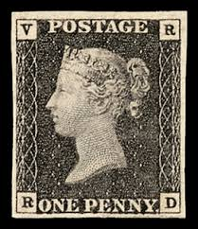  _______________________  _______________________  _______________________  _______________________

Let's move on now.
Sedaj pa nadaljujmo.

Take a look at the pictures. What do they have in common?
Oglej si slike. Kaj jim je skupnega?

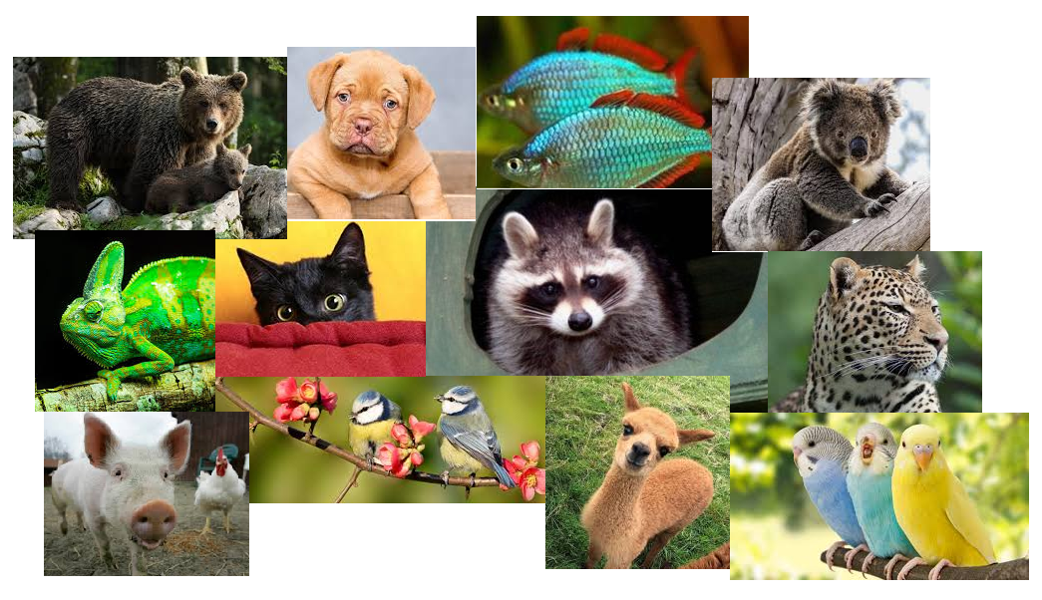

That’s right. Animals are in the pictures – pets, wild animals, exotic animals, farm animals.
Do you like animals? Which is your favourite animal? Why? (you don’t have to write anything down)
Tako je. Na sliki so živali – hišni ljubljenčki, divje živali, eksotične živali, domače živali.
Imaš rad/-a živali? Katera je tvoja najljubša žival? Zakaj? (ničesar ti ni treba zapisati)

Let’s see if you really are an animal lover. In your student’s book on p. 130 do the Animal Quiz (exercise 1 under section B2).
Pa poglejmo, če si res ljubitelj/-ica živali. V učbeniku na str. 130 reši kviz the Animal Quiz (nal. 1 pod razdelkom B2).

So, how did you do? I’m not sure if you noticed the score below the quiz. It gives you the result.
No, kako je šlo? Ne vem, če si opazil/-a “the score” pod kvizom. Poda ti rezultat.

Now, open your notebook and in the middle of the page put down the title Animals and write down the words you associate with this topic (see below).
Sedaj pa odpri zvezek in na sredino strani zapiši naslov Animals, nato pa zapiši besede, ki jih povezuješ s to temo (poglej spodaj).

a pet shop wild animals

the ZOO
Animals
endangered animals
(ogrožene živali)

the jungle an elephant

Have you ever been to a pet shop? Don’t worry if you haven’t.
You will listen to a conversation in a pet shop and do an exercise. First prepare the tape – find the enclosed mp3-file U4B2. Now open your SB on p. 131 and do ex. 2.
Ali si že kdaj bil/-a v trgovini z malimi živalmi? Ne skrbi, če nisi bil/-a.
Poslušal/-a boš posnetek v trgovini z malimi živalmi in naredil/-a nalogo. Najprej pripravi posnetek – poišči priložen mp3 U4B2. Sedaj odpri učb. na str. 131 in naredi 2. nalogo.

2. ura

To start the second hour of today’s lesson, in your notebook put down the title Pets and write down the words from ex. 2 on p. 131 in your student’s book and translate them.
Za začetek druge ure današnje lekcije, v zvezek napiši naslov Pets in izpiši besede iz naloge 2 na str. 131 v učbeniku in jih prevedi.
For example: Pets
Npr.:

a parrot – papiga; papagaj

If you have to, use the glossary.
Če je potrebno, si pomagaj s slovarčkom.

For the sake of the following exercise – even if you don’t have a pet, you do!
Open your notebook and do exercise 3 on p. 131 in your student’s book – write a dialogue of your own. Consider the given example. You don’t need a title, just continue where you left off.
Zaradi naslednje naloge – tudi če nimaš hišnega ljubljenčka, ga imaš!
Odpri svoj zvezek in naredi nalogo 3 na str. 131 v učbeniku – zapiši svoj pogovor. Upoštevaj dani vzorčni primer. Ne potrebuješ naslova, nadaljuj kjer si končal/-a.

In your student’s book on p. 132, ex. 4b: part 1, read a paragraph about puppies.
V učbeniku na str. 132, nal. 4b: prvi del (part one) preberi odstavek o kužkih.

Remember the “colour” legend.
Upoštevaj legendo “barv”.

Copy the questions below in your notebook and answer them.
Spodnja vprašanja prepiši v zvezek in nanje odgovori.

- How often does a puppy go for a walk?
- Can a puppy swim?
- How many meals does a puppy need?
- What does a puppy eat and drink?
- Do dogs like to be alone?

You will write down some questions about puppies in your notebook. The cues are below the paragraph in a green box. The first example is already done for you. Choose five more. Make sure you put down the questions in the singular.
Zapisal/-a boš vprašanja o kužkih v svoj zvezek. Iztočnice so pod odstavkom v zelenem okvirčku. Prvi primer je že narejen. Izberi jih še pet. Pazi, da vprašanja tvoriš v ednini.

How often does a puppy go out? How often do puppies go out?

You will write down questions about puppies in your notebook. The cues are below the paragraph in a green box. The first example is already done for you. Form questions in the singular.
Zapisal/-a boš vprašanja o kužkih v svoj zvezek. Iztočnice so pod odstavkom v zelenem okvirčku. Prvi primer je že narejen. Tvori vprašanja v ednini.

How often does a puppy go out? How often do puppies go out?

Now check exercise 2 on p. 131 in your SB. Here are the answers. You ticked:
Preveri nalogo 2 na str. 131 v učb. Tu so rešitve. Odkljukal/-a si:

a dog / a cat / a parrot / a canary / a guinea-pig / a rabbit / a snake

EXTRA or WHEN BORED:
Poišči ustrezno besedo:
https://speakspeak.com/english-grammar-exercises/elementary/animals-2
Poveži ustrezne izraze:
https://quizlet.com/11448572/match/embed/
Napiši ustrezen izraz:
https://quizlet.com/11448572/gravity
Poslušaj in poišči ustrezno žival:
http://www.eflnet.com/vocab/dictionary/animalsquiz4.php
Tvori vprašanja, da ugotoviš žival:
https://www.gamestolearnenglish.com/animal-mystery/



You have successfully completed another English lesson on your own.
Uspešno si končal/-a še eno samostojno učno uro.
Please send me an e-mail so that I will know how you are getting on.
Prosim, pošlji mi e-mail, da bom vedela, kako napreduješ.

Za dodatna vprašanja sva na voljo učiteljici angleščine:
- Vesna Možek Oblak: vesna.mozekoblak@ucitelj.oskm.si
- Ksenija Mrzel: ksenija.mrzel@ucitelj.oskm.si

