Dopolnilni pouk 5. VH - 1. teden
1. Postavi v pravilni vrstni red in zapiši stavke.
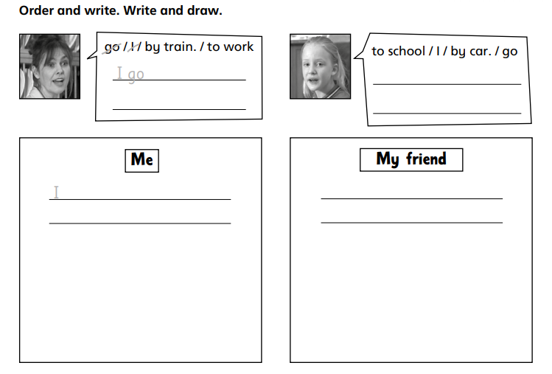
He /She goes to school by car/bus/bike. OR
He /She walks to school. OR
He /She goes to school on foot.
I walk to school. OR
I go to school by bike/car/bus.
I go to school by car.
I go to work by train.

2. Look at the town plan. Oglej si načrt mesta.
a) Write how do you get to Jane's party. You start at the cross.
Napiši, kako prideš do Janine zabave. Začni pri križcu spodaj.

b) Where are the buildings bellow? Read the instructions and write their names into the squares.
Kje so spodaj napisane stavbe? Preberi navodila in zapiši imena ustreznih stavb iz okvirčka v kvadratke na zemljevidu.
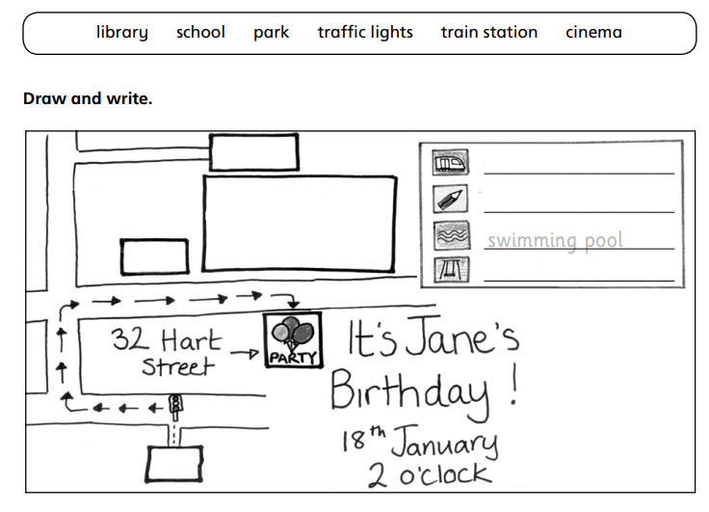
LIBRARY
Swimming
pool
SCHOOL
TRAIN STATION
PARK
b1) Excuse me, how do I get to the train station?
-Go straight on, at the traffic lights turn left. Then go straight on and turn right. Then go along the street. At the end of the street turn right and go straight on for about 50 meters. It's in front of you.
b2) Excuse me, how do I get to the park?
- Go straight on, at the traffic lights turn left. Then go straight on and turn right into Hart Street. The park is opposite the swimming pool. Jane's birthday party is at the pool.

b3) Excuse me, how do I get to the school?
-Go straight on, at the traffic lights turn left. Then go straight on and turn right into Hart Street. The school is on the left, next to the park.

b4) Excuse me, how do I get to the library?
-Go straight on, at the traffic lights turn left. Then go straight on and turn right. It's on your left.

