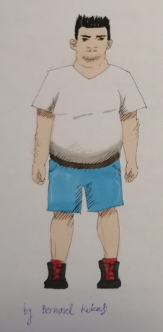

He is a man. He's short and fat.
He has got short black hair.
He's got black eyes.
He's got a beard (= brada).
He's got short arms and short legs.

OKRAJŠAVE:
He is = He's (ON je)
He has got = He's got (ON ima)

Uporabljamo Britansko pogovorno verzijo Has got!!

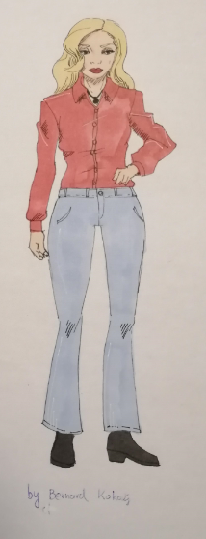

A baby* = dojenček / dojenčica
A boy = fant, deček
A man = moški
A teenager* = najstnik
A woman = ženska
A girl = dekle, deklica, punca
A teenager* = najstnica

*Za OBA spola je ista beseda.

She is a woman.
She's tall and thin.
She has got long blond hair.
She's got brown eyes.
She's got long arms and long legs.

OKRAJŠAVE:
She is = She's (ONA je)
She has got = She's got (Ona ima)

Fat = debel / debela
Thin = suh / suha
Tall = visok /visoka
Short = nizek / nizka (višina!!)
Long = dolg
Short = kratek

