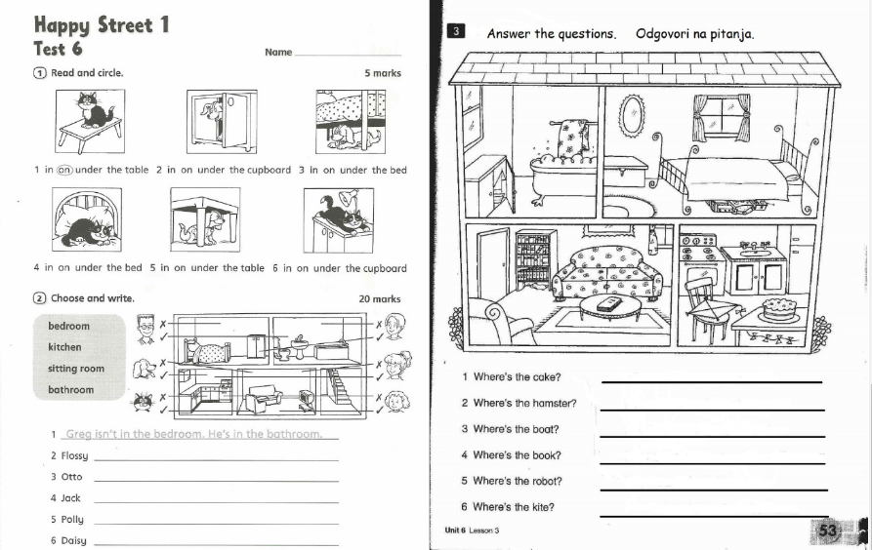
It's on the chair in the kitchen.
It's under the bed in the bedroom.
It's on the (coffee) tablein the sitting room/living room.
It's in the cupboard in the bathroom.
It's under the bookcase in the living room.
It's on the table in the kitchen.
isn't in the kitchen. She's in the living room.
isn't in the living room. She's in the kitchen.
isn't in the bathroom. He's in the bedroom.
isn't in the kitchen. He's in the living room.
isn't in the living room. She's in the kitchen.

