WHAT’S THE TIME?
What’s the time? Koliko je ura?
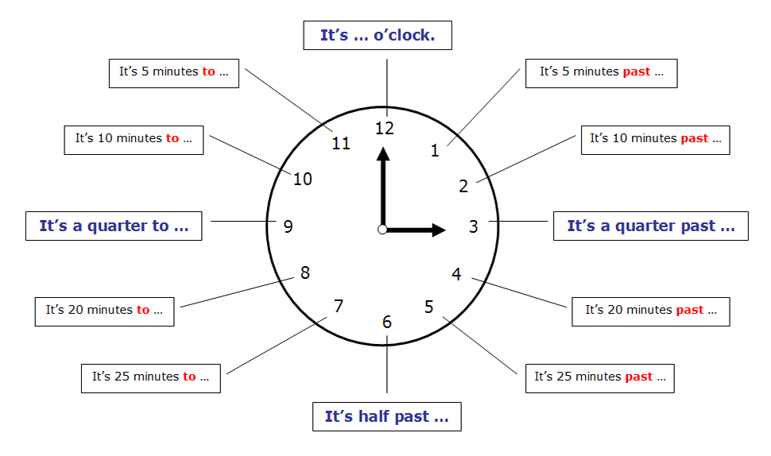
It’s … Ura je …

o’ clock točno ob uri
past čez
to do
half pol
quarter četrt
7:00 It’s seven o’clock.
7:05 It’s five past seven.
7:40 It’s twenty to eight.
7:30 It’s half past seven.
7:45 It’s quarter to eight.

POZOR!
pol osmih = half past seven
7:50 ten to eight

