AVTOR DANIEL DEFOE

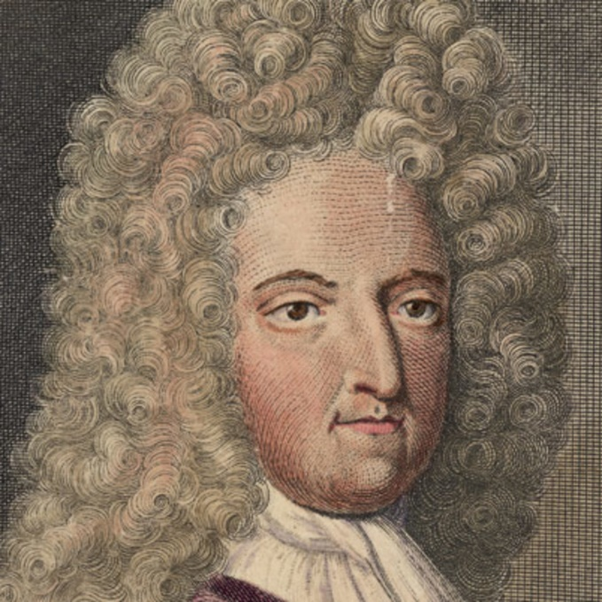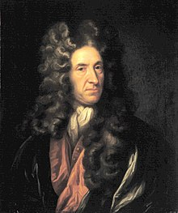

Daniel Defoe, angleški pisatelj, * ok. 1660, Stoke Newington, okrožje Londona, Anglija, † 24. april 1731, London.
Daniel Foe se je rodil v Angliji, leta 1659 v londonskem okrožju. Njegov oče je bil premožen svečar. Mladega Daniela je pri trinajstih letih poslal v šole, saj je upal, da bo sin postal duhovnik. Med svojim šolanjem na Akademiji v Londonu je Defoe imel sošolca po imenu Timothy Crusoe, ki naj bi dal ime junaku v romanu. Kasneje je leta 1678 opustil šolo in postal trgovec, lastnik ladij, politik, časnikar in poklicni pisatelj. Leta 1689 je izdal prvo knjigo in takrat se je tudi začel podpisovati Defoe ker mu je tako bolj imenitno zvenelo. Do konca življenja napisal okoli 300 romanov.
Leta 1684 se je poročil z Mary Tuffley. Rodila mu je osem otrok. Kasneje je postal izvrsten časnikar in si pridobil ime »oče sodobnega časnikarstva«. Vsa svoja pripovedna besedila je spisal po svojem šestdesetem letu. Prvo med temi besedili je bil Robinson Crusoe, nato pa še številna druga dela.
Zadnja leta so pisatelju močno zagrenile bolezen ter denarne in družinske težave. Umrl je 24. aprila 1731.

DELA
Prevedena dela v slovenščino:
- Robinson Crusoe (1719)
- Zgode in nezgode znamenite Moll Flanders (1722)
- Polkovnik Jack (1722)
- Spomini na leto kuge (1722)
- Roksana (1724)

Neprevedena dela:
- The Apparition of Mrs Veal (1706)
- The Ghost of Dorothy Dingley
- The Magician
- The Farther Adventures of Robinson Crusoe (1719)
- Tales of Piracy, Crime and Ghosts (1745)

O DELU
Dopolni manjkajoče podatke. Poslušaj razlago in preberi spremno besedo!

NADZVRSTA:

ZVRST:

PRIPOVEDOVALEC:

SNOV:

IDEJA

MOTIVI

ZGRADBA BESEDILA
a) zunanja - 24 poglavij

b) notranja

Kratka zgodba besedila
Robinson Crusoe se rodi leta 1632 v mestecu York. Že od malih nog ga silno zanimajo
ladje, morje in neraziskani svet. Kljub odsvetovanju staršev, odpluje na morje. Že na
svoji 1. plovbi doživi brodolom, vendar se posadka čudežno reši. Na drugem potovanju
pa jih pirati napadejo in tako Robinson preživi 2 leti v ujetništvu kakor služabnik, od
koder pobegne skupaj z nekim služabnikom. Iz morja ju reši portugalska ladja, ki ju
izkrca v Braziliji. Robinson tam postane vpliven in kar bogat. Vendar vseeno s svojim
življenjem ni zadovoljen. Leta 1659 se vkrca na ladjo za Novo Gvinejo. Robinson
ponovno doživi brodolom in se mu posreči rešiti na majhen otoček. Ladja je naplavila v
njegovo bližino tako da je bil oskrbljen s mnogimi življenjskimi potrebščinami. Sam na
otoku se zelo dobro znajde in si tako zgradi več bivališč, vzredi čredo ovc, se nauči
mnogih veščin za preživetje v naravi. V zadnjih letih svojega življenja na otoku reši
divjaka pred ljudožerci in ga poimenuje Petek. Na otoku tudi pristane neka ladja, na
kateri divja upor, ki pa ga Robinzon s pomočniki zatre. In se z to isto ladjo vrne nazaj v
rodno Anglijo, kjer ga čaka samo njegov oče in prijatelji. Novica se zelo hitro razširi po
tem majhnem mestecu in še isto noč priredijo zabavo na kateri Robinson razlaga o
njegovih dogodivščinah.

DOGAJALNI PROSTOR BESEDILA

DOGAJALNI ČAS BESEDILA

KNJIŽEVNE OSEBE IN NJIHOVA KARAKTERIZACIJA

Robinson Crusoe (glavna oseba) –

Petek (Robinsonov sluga) –

Robinsonovi starši –

Kapitan španske ladje in njegovi prijatelji/služabniki –

Ljudožerci –

INTERPRETACIJA
ODLOMEK STOPINJA
Odgovori na vprašanja!
1. Česa se Robinson ob odkritju ustraši, kako reagira in kaj sklene?
2. Katera čustva ga ob tem prevzamejo?
3. Katere lastnosti ga odlikujejo?
4. za Defojevo pisanje je značilno, da epizodam sledi refleksija, navadno o Božji previdnosti, ki ga je rešila. O čem razmišlja po odkritju človeške stopinje? Komu se zahvaljuje za svojo rešitev?
5. Kaj v njegovi refleksiji se vam zdi sprejemljivo in kaj ne?
6. V čem je Robinson podoben modernemu sleherniku?
7. kako se je skozi čas spreminjal družbeni odnos do civilizacije, narave, ekologije?
8. Kaj se je do danes zgodilo z naravo, ki jo je Robinson civiliziral s tolikšno vnemo, iznajdljivostjo, ljubeznijo?
9. Otok kot metaforo uporabi tudi Kovič v pesmi Južni otok. Primerjaj ju!

ODLOMEK 13 DNI NA OBALI
Odgovori na vprašanja!
Povzemi dogajanje iz odlomka!
Kaj je za brodolomca v tem položaju pomembno?
Kaj je popolnoma izgubilo vrednost glede na njegovo dotedanje življenje? Kaj je zanj tisto, kar poimenuje z besedo »bogastvo«?
Ali se vrednost bogastva spreminja tudi glede na človekov družbeni položaj, kraj bivanja, nacionalno in versko pripadnost, privzgojene družinske vrednote …?
Čemu se v življenju ne more upreti?
Kako ravna v stiski?
Kako ter o čem razmišlja?
Zakaj se avtor odloči za prvoosebno in dnevniško pripoved s potopisnimi prvinami? Kakšen učinek je s tem dosegel?
Napiši dnevnik o svojem potovanju v Nerezine. Upoštevaj vse značilnosti te besedilne vrste, predvsem to, da določiš čas zapisa in si izrazito oseben. Posebnost dnevniškega zapisa pa naj bodo potopisne prvine.

CITATI IZ KNJIGE

Izberi dva citata in ju razloži!

1. Pozneje sem pogosto opazil, da ljudje, posebno ko so mladi, nimajo za sramoto tistih dejanj, zaradi katerih jih imajo za bedake, mavreč gledajo kot na nekaj sramotnega na tista dobra in plemenita dela, ki jih počno v trenutkih kesanj, čeprav bi se prav zaradi teh dejanj lahko imeli za pametne.
2. Lepa je vsaka pot, samo da te pelje v prostost!
3. Ob pogledu na denar sem se nasmehnil. »Nepotrebno smetje.« Ves kup zlata bi dal za navaden nož.«
4. Tako sem imel koledar, ki je beležil dneve, mesece in leta.
5. Moj čas in delo sta bila poceni, a ni bilo vseeno, kako in zakaj ju zapravljam?
6. Toda moja razvneta domišljija je bila močnejša od razsodnosti in brez premisleka sem zgrabil za sekiro.
7. Moj otok – to je eden najlepših krajev na Zemlji.
8. Počemu govorite o strahu? Se sploh smemo česa bati? Karkoli nas zadane v prihodnosti, vse bo lažje od današnjega življenja. In vsak izhod iz tega položaja – celo smrt – moramo imeti za rešitev.
9. Ko sem zapuščal otok, sem vzel s sabo za spomin veliko koničasto kapo, ki sem jo bil sešil iz kozje kože, sončnik in eno izmed papig.

DNEVNIŠKI ZAPIS
- Priloga (str. 52, 53)

OSEBNI DNEVNIK
- ni namenjen javnosti, ampak ga avtor piše o sebi in navadno zase,
- najprej zapišemo datum, nekateri navedejo celo uro zapisa; zapisi so iskreni, saj pišemo brez miselnih, čustvenih ali kakšnih drugih zavor,
- vsebina: zapisujemo zunanje dogodke, doživetja, spoznanja, lastna razmišljanja, vtise, načrte, predvidevanja; pisec piše tudi o tistih trenutkih, mislih in čustvih v svojem življenju, o katerih noče govoriti z nikomer.

POTOPIS

Besedilo, v katerem sporočevalec pripoveduje o tem, kje je potoval in kaj je na svoji poti doživel, je potopis. V njem pisec oziroma govorec predstavlja značilnosti krajev, pokrajin, držav, njihove znamenitosti, ljudi in kulturo. Ker pri tem izraža tudi svoja mnenja in občutke, pravimo, da je potopis subjektivno besedilo.
Glagoli so po navadi v 1. osebi ednine, dvojine ali množine in večinoma pretekliku, saj sporočevalec pripoveduje o svojih preteklih doživetjih.

*Tudi ti zapiši potek šole v naravi in vtise, ki si jih pridobil med bivanjem v Nerezinah, v obliki dnevnika z značilnostmi potopisa.

PREŽIVETJE V NARAVI IN DRUŽBI

Preberi ključne informacije o preživetju v naravi in odgovori na vprašanja, povezana s knjigo!

Kako in kje Robinson postavi bivališče. S kakšnimi težavami se srečuje?
Kaj prinese z ladje?
Katero orodje izdela sam?
Ali ima težave s pitno vodo? Kako jih reši?
Kako udomači živali? Katere živali mu delajo družbo, katere mu služijo kot hrana.
Kako se loti poljedelstva? S kakšnimi težavami se srečuje?
Kaj ugotovi o otoku in dostopnosti do njega?
Kako se spopada s samoto in koliko časa živi sam?
Katere lastnosti mu pomagajo pri preživetju?
Ali izdeluje koledar in zakaj?
Kako se odzove na divjake, ljudožerstvo in na novega prijatelja?
Kaj Petka nauči in kaj občuduje pri njem?
Kako se odzove na »bele goste«? Kako ravna z ujetniki?
Kaj ga ob vrnitvi v domovino preseneti?
Kako vnovči svoje samotno bivanje po prihodu v Anglijo?

GEOGRAFIJA

Površina: 47,94 km²
Nadmorska višina: 915 m
Prebivalstvo: 859 (2011)
Skupina otokov: Juan Fernández Islands
Provinca: Valparaíso Province
Sosednje vodno telo: Tihi ocean

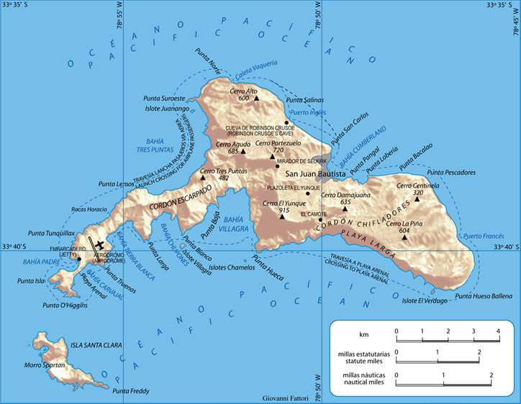

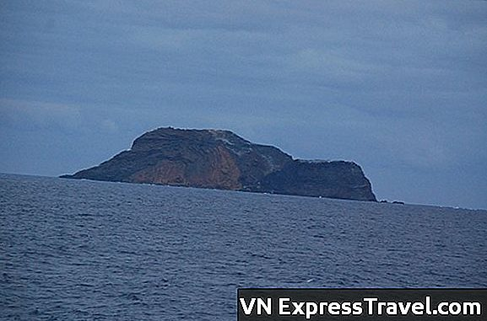

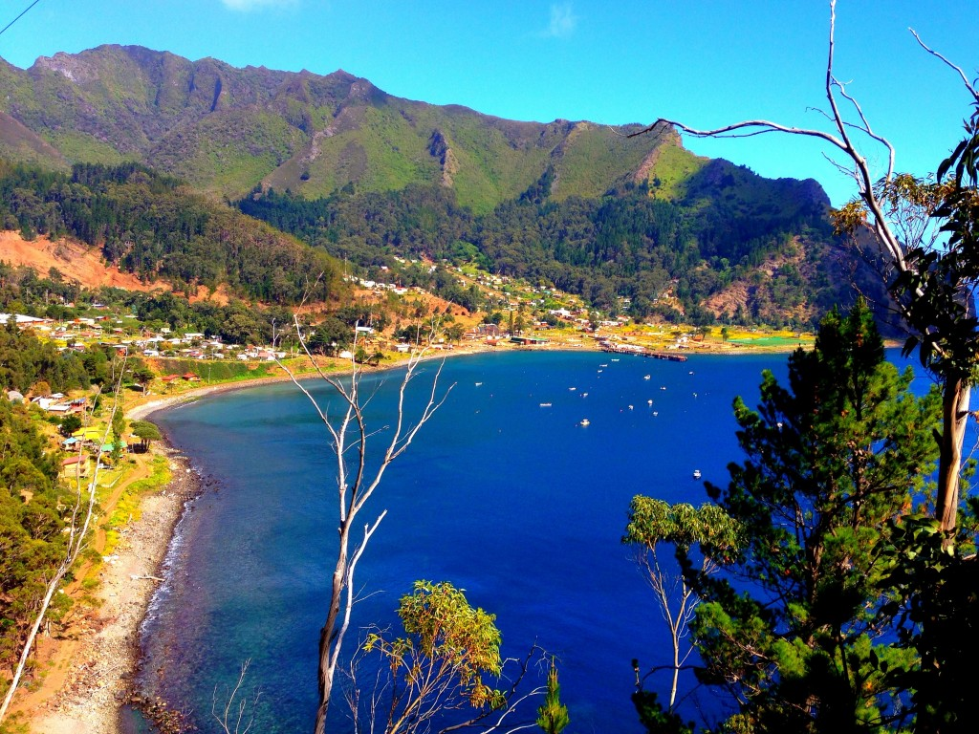

ANGLEŠČINA

Besedilo preberi v angleškem jeziku in naredi povzetek v slovensščini.

ROBINSON CRUSOE
Crusoe’s success in mastering his situation, overcoming his obstacles, and controlling his environment shows the condition of mastery in a positive light, at least at the beginning of the novel. Crusoe lands in an inhospitable environment and makes it his home. His taming and domestication of wild goats and parrots with Crusoe as their master illustrates his newfound control. Moreover, Crusoe’s mastery over nature makes him a master of his fate and of himself. Early in the novel, he frequently blames himself for disobeying his father’s advice or blames the destiny that drove him to sea. But in the later part of the novel, Crusoe stops viewing himself as a passive victim and strikes a new note of self-determination. In building a home for himself on the island, he finds that he is master of his life—he suffers a hard fate and still finds prosperity.
But this theme of mastery becomes more complex and less positive after Friday’s arrival, when the idea of mastery comes to apply more to unfair relationships between humans. In Chapter XXIII, Crusoe teaches Friday the word “[m]aster” even before teaching him “yes” and “no,” and indeed he lets him “know that was to be [Crusoe’s] name.” Crusoe never entertains the idea of considering Friday a friend or equal—for some reason, superiority comes instinctively to him. We further question Crusoe’s right to be called “[m]aster” when he later refers to himself as “king” over the natives and Europeans, who are his “subjects.” In short, while Crusoe seems praiseworthy in mastering his fate, the praiseworthiness of his mastery over his fellow humans is more doubtful. Defoe explores the link between the two in his depiction of the colonial mind.

Symbols
Symbols are objects, characters, figures, or colors used to represent abstract ideas or concepts.

The Footprint
Crusoe’s shocking discovery of a single footprint on the sand in Chapter XVIII is one of the most famous moments in the novel, and it symbolizes our hero’s conflicted feelings about human companionship. Crusoe has earlier confessed how much he misses companionship, yet the evidence of a man on his island sends him into a panic. Immediately he interprets the footprint negatively, as the print of the devil or of an aggressor. He never for a moment entertains hope that it could belong to an angel or another European who could rescue or befriend him. This instinctively negative and fearful attitude toward others makes us consider the possibility that Crusoe may not want to return to human society after all, and that the isolation he is experiencing may actually be his ideal state.

The Cross
Concerned that he will “lose [his] reckoning of time” in Chapter VII, Crusoe marks the passing of days “with [his] knife upon a large post, in capital letters, and making it into a great cross . . . set[s] it up on the shore where [he] first landed. . . .” The large size and capital letters show us how important this cross is to Crusoe as a timekeeping device and thus also as a way of relating himself to the larger social world where dates and calendars still matter. But the cross is also a symbol of his own new existence on the island, just as the Christian cross is a symbol of the Christian’s new life in Christ after baptism, an immersion in water like Crusoe’s shipwreck experience. Yet Crusoe’s large cross seems somewhat blasphemous in making no reference to Christ. Instead, it is a memorial to Crusoe himself, underscoring how completely he has become the center of his own life.

Crusoe’s Bower
On a scouting tour around the island, Crusoe discovers a delightful valley in which he decides to build a country retreat or “bower” in Chapter XII. This bower contrasts sharply with Crusoe’s first residence, since it is built not for the practical purpose of shelter or storage, but simply for pleasure: “because I was so enamoured of the place.” Crusoe is no longer focused solely on survival, which by this point in the novel is more or less secure. Now, for the first time since his arrival, he thinks in terms of “pleasantness.” Thus, the bower symbolizes a radical improvement in Crusoe’s attitude toward his time on the island. Island life is no longer necessarily a disaster to suffer through, but may be an opportunity for enjoyment—just as, for the Presbyterian, life may be enjoyed only after hard work has been finished and repentance achieved.

Motives

Motives are recurring structures, contrasts, or literary devices that can help to develop and inform the text’s major themes.

Counting and Measuring
Crusoe is a careful note-taker whenever numbers and quantities are involved. He does not simply tell us that his hedge encloses a large space, but informs us with a surveyor’s precision that the space is “150 yards in length, and 100 yards in breadth.” He tells us not simply that he spends a long time making his canoe in Chapter XVI, but that it takes precisely twenty days to fell the tree and fourteen to remove the branches. It is not just an immense tree, but is “five foot ten inches in diameter at the lower part . . . and four foot eleven inches diameter at the end of twenty-two foot.” Furthermore, time is measured with similar exactitude, as Crusoe’s journal shows. We may often wonder why Crusoe feels it useful to record that it did not rain on December 26, but for him the necessity of counting out each day is never questioned. All these examples of counting and measuring underscore Crusoe’s practical, businesslike character and his hands-on approach to life. But Defoe sometimes hints at the futility of Crusoe’s measuring—as when the carefully measured canoe cannot reach water or when his obsessively kept calendar is thrown off by a day of oversleeping. Defoe may be subtly poking fun at the urge to quantify, showing us that, in the end, everything Crusoe counts never really adds up to much and does not save him from isolation.

Eating
One of Crusoe’s first concerns after his shipwreck is his food supply. Even while he is still wet from the sea in Chapter V, he frets about not having “anything to eat or drink to comfort me.” He soon provides himself with food, and indeed each new edible item marks a new stage in his mastery of the island, so that his food supply becomes a symbol of his survival. His securing of goat meat staves off immediate starvation, and his discovery of grain is viewed as a miracle, like manna from heaven. His cultivation of raisins, almost a luxury food for Crusoe, marks a new comfortable period in his island existence. In a way, these images of eating convey Crusoe’s ability to integrate the island into his life, just as food is integrated into the body to let the organism grow and prosper. But no sooner does Crusoe master the art of eating than he begins to fear being eaten himself. The cannibals transform Crusoe from the consumer into a potential object to be consumed. Life for Crusoe always illustrates this eat or be eaten philosophy, since even back in Europe he is threatened by man-eating wolves. Eating is an image of existence itself, just as being eaten signifies death for Crusoe.

Ordeals at Sea
Crusoe’s encounters with water in the novel are often associated not simply with hardship, but with a kind of symbolic ordeal, or test of character. First, the storm off the coast of Yarmouth frightens Crusoe’s friend away from a life at sea, but does not deter Crusoe. Then, in his first trading voyage, he proves himself a capable merchant, and in his second one, he shows he is able to survive enslavement. His escape from his Moorish master and his successful encounter with the Africans both occur at sea. Most significantly, Crusoe survives his shipwreck after a lengthy immersion in water. But the sea remains a source of danger and fear even later, when the cannibals arrive in canoes. The Spanish shipwreck reminds Crusoe of the destructive power of water and of his own good fortune in surviving it. All the life-testing water imagery in the novel has subtle associations with the rite of baptism, by which Christians prove their faith and enter a new life saved by Christ.

Robinson Crusoe
While he is no flashy hero or grand epic adventurer, Robinson Crusoe displays character traits that have won him the approval of generations of readers. His perseverance in spending months making a canoe, and in practicing pottery making until he gets it right, is praiseworthy. Additionally, his resourcefulness in building a home, dairy, grape arbor, country house, and goat stable from practically nothing is clearly remarkable. The Swiss philosopher Jean-Jacques Rousseau applauded Crusoe’s do-it-yourself independence, and in his book on education, Emile, he recommends that children be taught to imitate Crusoe’s hands-on approach to life. Crusoe’s business instincts are just as considerable as his survival instincts: he manages to make a fortune in Brazil despite a twenty-eight-year absence and even leaves his island with a nice collection of gold. Moreover, Crusoe is never interested in portraying himself as a hero in his own narration. He does not boast of his courage in quelling the mutiny, and he is always ready to admit unheroic feelings of fear or panic, as when he finds the footprint on the beach. Crusoe prefers to depict himself as an ordinary sensible man, never as an exceptional hero.
But Crusoe’s admirable qualities must be weighed against the flaws in his character. Crusoe seems incapable of deep feelings, as shown by his cold account of leaving his family—he worries about the religious consequences of disobeying his father, but never displays any emotion about leaving. Though he is generous toward people, as when he gives gifts to his sisters and the captain, Crusoe reveals very little tender or sincere affection in his dealings with them. When Crusoe tells us that he has gotten married and that his wife has died all within the same sentence, his indifference to her seems almost cruel. Moreover, as an individual personality, Crusoe is rather dull. His precise and deadpan style of narration works well for recounting the process of canoe building, but it tends to drain the excitement from events that should be thrilling. Action-packed scenes like the conquest of the cannibals become quite humdrum when Crusoe narrates them, giving us a detailed inventory of the cannibals in list form, for example. His insistence on dating events makes sense to a point, but it ultimately ends up seeming obsessive and irrelevant when he tells us the date on which he grinds his tools but neglects to tell us the date of a very important event like meeting Friday. Perhaps his impulse to record facts carefully is not a survival skill, but an irritating sign of his neurosis.
Finally, while not boasting of heroism, Crusoe is nonetheless very interested in possessions, power, and prestige. When he first calls himself king of the island it seems jocund, but when he describes the Spaniard as his subject we must take his royal delusion seriously, since it seems he really does consider himself king. His teaching Friday to call him “Master,” even before teaching him the words for “yes” or “no,” seems obnoxious even under the racist standards of the day, as if Crusoe needs to hear the ego-boosting word spoken as soon as possible. Overall, Crusoe’s virtues tend to be private: his industry, resourcefulness, and solitary courage make him an exemplary individual. But his vices are social, and his urge to subjugate others is highly objectionable. In bringing both sides together into one complex character, Defoe gives us a fascinating glimpse into the successes, failures, and contradictions of modern man.

Friday
Probably the first nonwhite character to be given a realistic, individualized, and humane portrayal in the English novel, Friday has a huge literary and cultural importance. If Crusoe represents the first colonial mind in fiction, then Friday represents not just a Caribbean tribesman, but all the natives of America, Asia, and Africa who would later be oppressed in the age of European imperialism. At the moment when Crusoe teaches Friday to call him “Master” Friday becomes an enduring political symbol of racial injustice in a modern world critical of imperialist expansion. Recent rewritings of the Crusoe story, like J. M. Coetzee’s Foe and Michel Tournier’s Friday, emphasize the sad consequences of Crusoe’s failure to understand Friday and suggest how the tale might be told very differently from the native’s perspective.
Aside from his importance to our culture, Friday is a key figure within the context of the novel. In many ways he is the most vibrant character in Robinson Crusoe, much more charismatic and colorful than his master. Indeed, Defoe at times underscores the contrast between Crusoe’s and Friday’s personalities, as when Friday, in his joyful reunion with his father, exhibits far more emotion toward his family than Crusoe. Whereas Crusoe never mentions missing his family or dreams about the happiness of seeing them again, Friday jumps and sings for joy when he meets his father, and this emotional display makes us see what is missing from Crusoe’s stodgy heart. Friday’s expression of loyalty in asking Crusoe to kill him rather than leave him is more heartfelt than anything Crusoe ever says or does. Friday’s sincere questions to Crusoe about the devil, which Crusoe answers only indirectly and hesitantly, leave us wondering whether Crusoe’s knowledge of Christianity is superficial and sketchy in contrast to Friday’s full understanding of his own god Benamuckee. In short, Friday’s exuberance and emotional directness often point out the wooden conventionality of Crusoe’s personality.
Despite Friday’s subjugation, however, Crusoe appreciates Friday much more than he would a mere servant. Crusoe does not seem to value intimacy with humans much, but he does say that he loves Friday, which is a remarkable disclosure. It is the only time Crusoe makes such an admission in the novel, since he never expresses love for his parents, brothers, sisters, or even his wife. The mere fact that an Englishman confesses more love for an illiterate Caribbean ex-cannibal than for his own family suggests the appeal of Friday’s personality. Crusoe may bring Friday Christianity and clothing, but Friday brings Crusoe emotional warmth and a vitality of spirit that Crusoe’s own European heart lacks.

The Portuguese Captain
The Portuguese captain is presented more fully than any other European in the novel besides Crusoe, more vividly portrayed than Crusoe’s widow friend or his family members. He appears in the narrative at two very important junctures in Crusoe’s life. First, it is the Portuguese captain who picks up Crusoe after the escape from the Moors and takes him to Brazil, where Crusoe establishes himself as a plantation owner. Twenty-eight years later, it is again the Portuguese captain who informs Crusoe that his Brazilian investments are secure, and who arranges the sale of the plantation and the forwarding of the proceeds to Crusoe. In both cases, the Portuguese captain is the agent of Crusoe’s extreme good fortune. In this sense, he represents the benefits of social connections. If the captain had not been located in Lisbon, Crusoe never would have cashed in on his Brazilian holdings. This assistance from social contacts contradicts the theme of solitary enterprise that the novel seems to endorse. Despite Crusoe’s hard individual labor on the island, it is actually another human being—and not his own resourcefulness—that makes Crusoe wealthy in the end. Yet it is doubtful whether this insight occurs to Crusoe, despite his obvious gratitude toward the captain.
Moreover, the Portuguese captain is associated with a wide array of virtues. He is honest, informing Crusoe of the money he has borrowed against Crusoe’s investments, and repaying a part of it immediately even though it is financially difficult for him to do so. He is loyal, honoring his duties toward Crusoe even after twenty-eight years. Finally, he is extremely generous, paying Crusoe more than market value for the animal skins and slave boy after picking Crusoe up at sea, and giving Crusoe handsome gifts when leaving Brazil. All these virtues make the captain a paragon of human excellence, and they make us wonder why Defoe includes such a character in the novel. In some ways, the captain’s goodness makes him the moral counterpart of Friday, since the European seaman and the Caribbean cannibal mirror each other in benevolence and devotion to Crusoe. The captain’s goodness thus makes it impossible for us to make oversimplified oppositions between a morally bankrupt Europe on the one hand, and innocent noble savages on the other.

ZANIMIVOSTI O KNJIGI, OTOKU, AVTORJU

O AVTORJU

O DELU

O OTOKU

O ŠOLI V NARAVI

