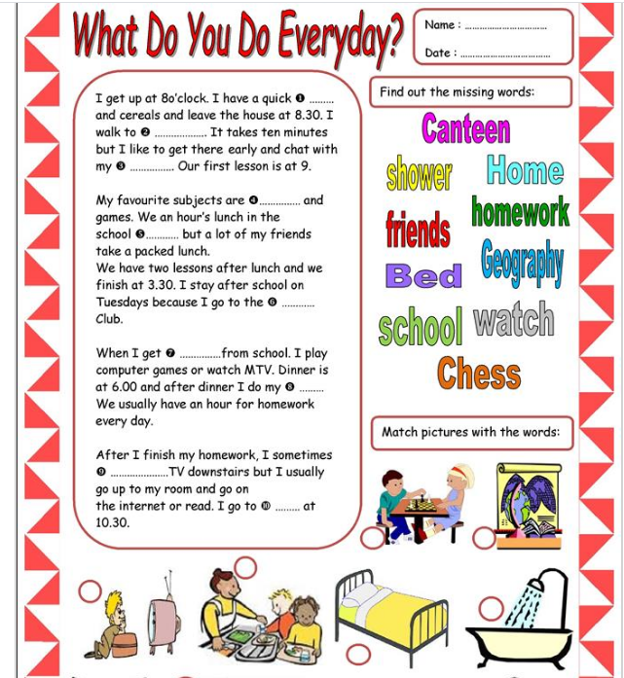

Vir: https://en.islcollective.com/english-esl-worksheets/vocabulary/daily-routines/what-do-you-do-everyday/36117

