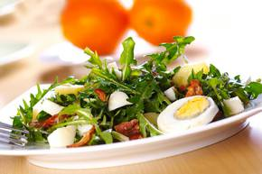
Dandelion salad
Ingredients:
250 g (8 3/4 oz) dandelion greens
80 g (2 4/5 oz) smoked bacon
2 potatoes
2 eggs
vinegar, olive oil
Dandelion salad. Photo: Tomo Jeseničnik
salt, pepper

Instructions:
Cook the potatoes and hard boil the eggs. Cut dandelion greens into small pieces. Peel and slice potatoes and eggs, and mix with dandelion greens. Season with salt and pepper.
Chop the bacon and fry it in a pan until crispy. Sprinkle over dandelion salad, add oil and vinegar, and toss well.

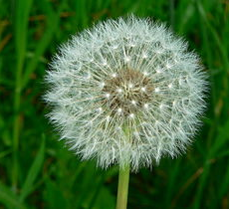
DID YOU KNOW?
A dandelion is a flower.
Two..species, Taraxacum officinale and Taraxacum erythrospermum, are found as weeds worldwide.
All parts of both species are edible.
(You can eat them.)

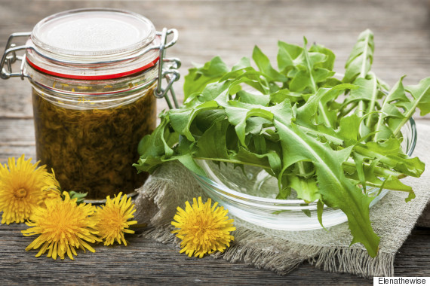

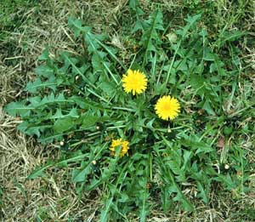

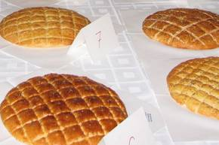
Belokranjska pogača (salted cake)

Ingredients:
1 kg flour
2 tbs salt
1 tbs sugar
2 tbs oil
Photo: M.B.J., source: Dolenjskilist.si.
2 packages of dried yeast
Approx. 0,7 l warm water

Instructions:
Mix all the ingredients and form a dough. Leave to rise for 30 minutes. Spread the dough evenly onto a baking tray, slice it into squares and glaze it with the beaten egg. The cake can be sprinkled with salt. Bake in a pre-heated oven for approximately 45 minutes at 200°C.

Traditionally, guests in Slovenia get a freshly baked pogača. They tear a piece off and eat it. It's a sign of being welcome into the house of their hosts.
This flatbread comes from the Slovenian region of Bela Krajina (also known as White Carniola in English).
Pogača – Slovenia’s Traditional Welcome Bread

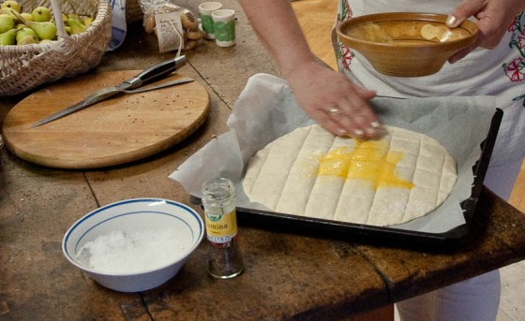
(Source: http://rossiwrites.com/travel/slovenia/pogaca-slovenia-traditional-welcome-bread/)

