Class 9,3rd WEEK, 6th April – 10th April 2020

How are you? Ready for some English? I'm sure you'll do great! So…Let's start!
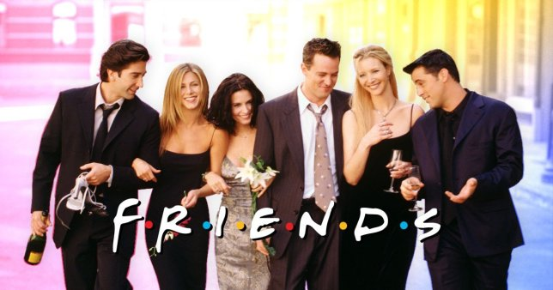
- Oglej si video https://www.youtube.com/watch?v=aI9XSc1f-Xo in s pomočjo serije Friends ponovi oba tipa if- stavkov, ki smo jih spoznali do sedaj. Video si oglej do minute 7.
If-stavki? Kaj je že to? Si pozabil? Oglej si spodnjo razpredelnico. Večkrat jo preberi in nato prepiši v zvezek.

The first and second conditional – comparison
1. in 2. pogojnik – primerjava

1. pogojnik: present simple in will

If I buy a car, I'll drive to Italy.
Če bom kupil avto, se bom peljal v Italijo.

If I see my friend, I'll be really happy.
Če bom videl prijatelja, bom zelo vesel.

2. pogojnik: past simple in would

If I bought a car, I would drive to Italy.
Če bi kupil avto, bi se peljal v Italijo.

If I saw my friend, I would be really happy.
Če bi videl prijatelja, bi bil zelo srečen.

3. Poznamo še tako imenovani »zero conditional« ali pogojnik 0.

If (When) it rains, I take an umbrella. – Če dežuje, vzamem dežnik.
If (When) it's hot, I wear shorts. – Če je vroče, nosim kratke hlače.
If I drink coca-cola, I don't feel well. – Če pijem kokakolo, se ne počutim dobro.

V DZ reši vaje 20, 21, 22 na str. 101, 102. Pazi na tvorbo dveh tipov if-stavkov.
Na koncu tega dokumenta imaš rešitve vaj. Ko vaje opraviš, preglej.

2. FRIENDSHIP

Watch the video: https://www.youtube.com/watch?v=pXB5lxHKjV4
What does friendhisp mean to you? Who is a true friend? How many friends have you got?

V UČB na str. 115 pri nalogi 1 preberi citate o prijateljstvu. Izberi si dva, ju zapiši v zvezek in dodaj svoj komentar oz. razlago citata. Uporabi angleški jezik.

Primer:
Friendship is a plant which must often be watered.
I absolutely agree with this statement. As a plant would wither away without water so our friendship would end without constant ‘water’ – love and understanding. I couldn’t agree more.

What makes a good friend? V UČB na str. 116 / vaja 3 poslušaj 4 osebe, ki govorijo o prijateljstvu. V okvirček zapiši, kaj za njih pomeni prijateljstvo. Posnetek najdeš na povezavi:
https://touchstone.si/audio/ts9/116_What_makes_a_good_friend.mp3

UČB 116 / vaja 4: napiši številke od 1 – 8 glede na to, kako pomembno se ti zdi našteto za prijateljstvo.

Well, this is it! Have a great week and stay healthy!

Teacher Tina

Don't forget…on the next page you will find solutions to the exercises in the workbook.

SOLUTIONS of exercises in the workbook
20
2 broke out
3 are
4 will melt
5 were/was
6 goes
7 weren’t/wasn’t
8 don’t give up
9 had
21
1 If she joined a club, she’d make more friends.
2 If you eat so much, you’ll be fat.
3 If I found a fly in my soup, I’d complain to the manager.
4 If I saw a ghost, I’d run away.
5 If the dog keeps barking, the neighbours will wake up.
6 I’d buy that bag, it were cheaper.
22
1 If I had a compass, I would be able to find the way.
2 If I had a mobile phone, I would be able to call my
parents.
3 If it weren’t so dark, I wouldn’t feel scared.
4 If I build a shelter, I won’t sleep under the trees.
5 If I had a bottle, I would be able to send a message.
6 If there weren’t so too many sharks, I would be able to
escape.
7 If I had company, I wouldn’t feel lonely.
8 If I make an axe, I will be able to make a raft.
9 If I put on some sunscreen, I won’t get sunburnt.
10 If I had a bow and arrows, I would be able to capture
game or birds.
11 If I wear an insect head net, insects won’t bite me.
12 If I had night vision binoculars, I would be able to see
everything by night.
13 If I use water purification tablets, I’ll be able to purify
water and drink it.
14 If I had a shovel, I would be able to build an igloo.
15 If I had fishhooks, I would be able to catch fish.

