COLOUR THE SHAPES IN THE EASTER EGG.
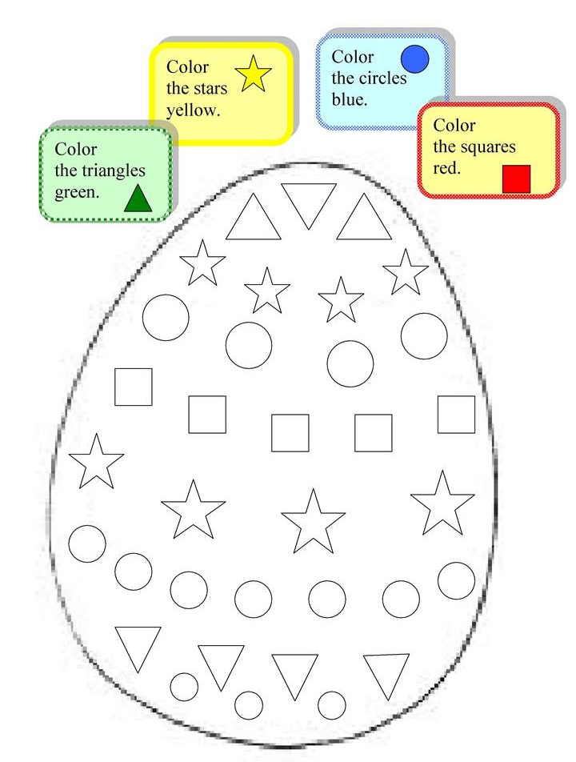
POBARVAJ LIKE V VELIKONOČNEM JAJCU.

