3. PODNEBJE IN RASTLINSTVO
-__________________________________
-__________________________________
-__________________________________
1. LEGA
________________________________________________________________________________________________

NOVA ZELANDIJA
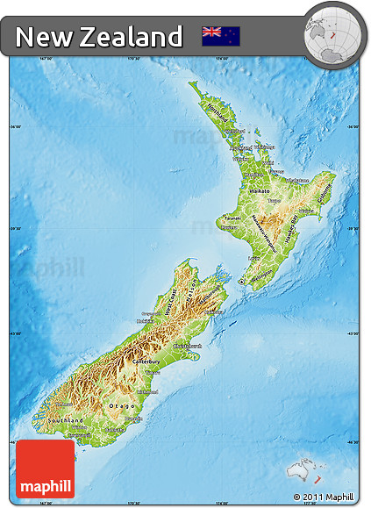
UČ. 39-41
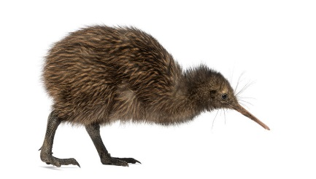
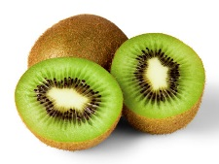
4. PREBIVALSTVO IN POSELITEV
______________________________________________________________________________________________________________________________________________________________________________________________________
____________________
5.KMETIJSTVO____________________________________________________________________
6. GOSPODARSTVO_______________________________________________________________
____________________________________________________________________________________________
2. POVRŠJE
_________________________________
_________________________________
_________________________________

__________________________________
__________________________________
__________________________________

