Rešitve 4. teden TJA 5. H in 5. V

1. URA TJA:
-DZ. str. 62, 1. nal:
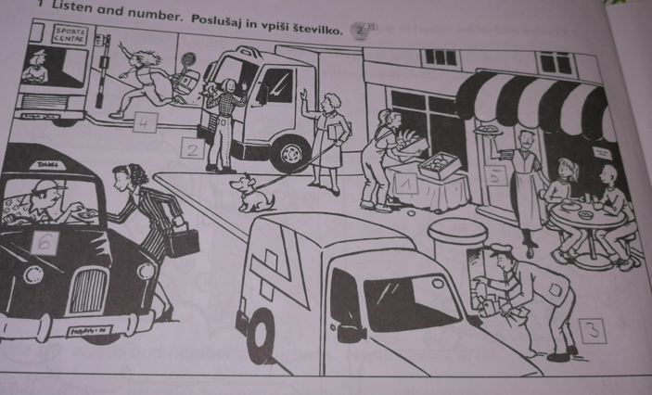
-DZ str. 62, 2. nal.:
1 Annette
2 Henry
3 Annette
4 Annette
5 Henry
6 Henry

-DZ str. 63, nal. 3:
2. He wears a uniform.
3. She works in a restaurant.
4. She drives a train.
5. He works in a school.
6. He drives a bus.

-Prepriši in nariši 4 posamezne delčke pesmice:
To pogledam vsakemu posebej.

2. Ura TJA:
-Učb. str. 51:
-10 stavkov o Amy. To pogledam vsakemu posebej, ko mi pošljete..

-DZ str. 64: Nal. 1:
1B
2A
3B
4B
5A
6B
7A
8A

-DZ str. 64, nal. 2.:
Whose bag is this? = Čigava torba je tole?
It's AMANDA's. (Je Amandina)

