QUIZ 1 CLASS 5
1. Glej načrt mesta in povej napotke za pot do … Uporabi besede iz okvirčka spodaj. Kakšno besedo lahko uporabiš večkrat, nekatere so odveč. 7 T
A: Excuse me, can you tell me the way to the RESTAURANT, please?
B: Cartainly, turn ______, then turn ________. Go _____________ the sports centre. Go _________ . The restaurant is on _________________.
right past left straight your
city church library go between

2. Obkroži a, b ali c. 10 T
1. The Tube is the London _____ .
a) city b) taxi c) underground

2. In London, there's a river called ______.
a) the Mississippi b) the Thames c) the blurb

3. Who _______ playing tennis?
a) does b) like c) likes

4. My friend loves _____________ books.
a) play b) riding c) reading

5. I visit my uncle _____ Saturdays.
a) in b) at c) on

6. After Tuesday there comes ________ .
a) Monday b) Friday c) Wednesday

7. New Year's Eve is _____________ .
a) in December b) on December c) in January

8. A nurse ___________ a thermometer.
a) ues b) uses c) don't use

9. A firefighter uses a ______ and ______ .
a) spanner, computer b) fire engine, hose c) fire, hose

10. A postman _______ a postmans van and ___________ a postman's hat.
a) drives, wears b) wears, drives c) rides, has

3. Preberi in obkroži ustrezne besede (levo ali desno od poševnice) 8 T .
1. A hedgehog is smaller / bigger than a bat.
2. In Scotland there's a big lake / river with Nessie the monster.
3. In Legoland Windsor there's a mountain / rollercoaster called The Dragon.
4. In Scotland, there is beautiful countryside / bubbles.
5. I usually go to school on / by foot.
6. My favourite TV programme / channel is called The Thundermans. It's in /on Nickelodeon every day.
7. My Mum like /likes watching romantic films.

4. Preberi opis za Rachel in zraven spodnjih trditev napiši, če držijo (True=T) ali ne držijo (False=F). 8 T
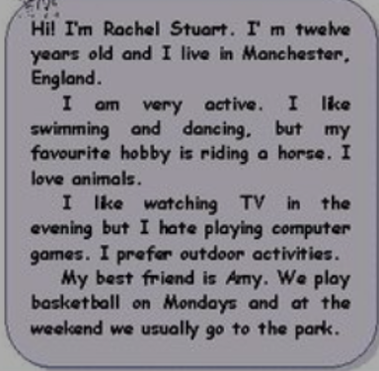
1. Rachael is from the USA.
2. She doesn't like playing computer games.
3. Her favourite free time activity is riding a horse.
4. She doesn't play basketball.
5. At the weekend she goes to the park with Amy.
6. She watches television in the morning.
7. She can swim.
8. She can't dance.

5. Vstavi ustrezne glagole it spodnje tabele. Nekatere lahko uporabiš večkrat.
MY DAY 15 T
I _____ at seven o'clock. Then I ________ a shower at quarter past seven and _______ dressed. I ______ breakfast at half past seven. After that I ______ to »online school« in quarantine.
After two lessons I _______ a break and a snack. At about one o'clock I ______ all my homework. I _______ lunch at about two o'clock. In the afternoon I ______ outside.
I _______ dinner at 7 p.m. . After that I ______ TV or _______ computer games. I sometimes ______ my parents. Or I ____ my grandparents.
I ______ my teeth and _______ to bed at nine.
help | watch | get | go | play
brush | get up | have | do | call

