QUIZ 1 Class 4. H and 4. V Week 5
1. Zapiši številke z besedo. Uporabi male tiskane črke. 6T
12 ___________________ 20 ____________________
15 __________________ 13 _____________________
19 ___________________ 11 ____________________

2. Natipkaj imena kosov pohištva z malimi tiskanimi črkami. 9T
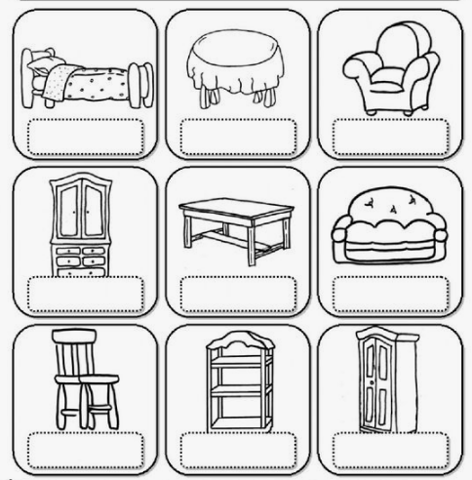
9
8
7
6
5
4
3
2
1
Vir slike: https://www.pinterest.com/pin/426153183480557837/
1
2
3
4
5
6
7
8
9

3. Preberi in poveži. Odgovore (številke) napiši v tabelo. 7 T
a. What's your favourite toy? 1. No, I haven´t.
b. Do you like peppers? 2. It's a big grey house.
c. What´s this? 3. Yes, I do.
d. Have you got a kite? 4. It´s under the bed.
e. Where's my doll? 5. No, he isn't. He's from the UK.
f. Where's the bath? 6. It's a teddy-bear.
g. Is Jack from Slovenia? 7. It's in the bathroom.

a | b | c | d | e | f | g

4. Izberi ustrezno osebo. Vpiši številko v ustrezno okence. 7 T
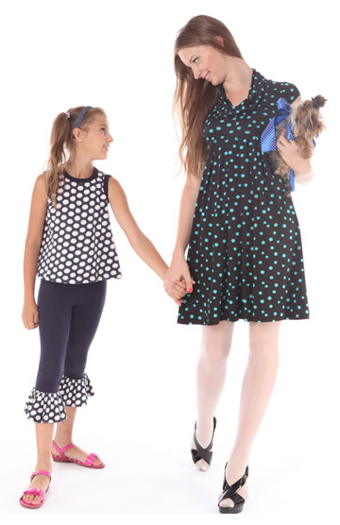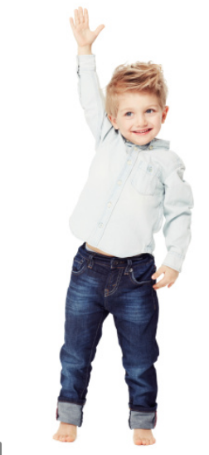
1 2 3 4 5 6 7
a) She's fat and tall. She's got long brown hair.
b) He's old, he's got glasses.
c) He's fat and tall. He's got short brown hair.
d) He's short and young.
e) She's tall and thin. She's got long brown hair.
f) She isn't young, she's got grey hair and glasses.
g) She's short, thin and young.
Viri slik: https://www.vectorstock.com/royalty-free-vector/fat-woman-fat-man-thick-couple-vector-22979722
http://geniuspregnancy.com/news/fit-parents-have-thin-children.html
https://www.istockphoto.com/photo/growing-up-big-and-tall-gm459231457-31894672
https://www.vectorstock.com/royalty-free-vector/old-man-and-woman-with-shopping-cart-vector-10834454

