7. 5. 2020 | TJA – 7. razred | Describing a Town; Revision Exercises 2 uri

Dear pupil,

I know distance education takes much more effort, but take a look on the bright side – you’ve acquired some new skills, you may have become more organized and independent in carrying out the tasks. However, if or when troubles occur, please, contact me.

All the best to you and your family. Stay safe and sound.

Your English teacher

Spodnjo legendo že dodobra poznaš. Sam/-a se odloči, kolikšno količino nalog boš opravil/-a.

Legenda:
temno modra – rešitve nalog prejšnje ure (morajo pregledati vsi učenci)
črna – naloge morajo narediti vsi; minimalna zahtevnost
modra – naloge naredijo tisti, ki so pri pouku uspešnejši; a jih lahko delajo tudi tisti, ki si to želijo
vijolična – dodatne naloge; če si želiš več utrjevanja ali ko ti je dolgčas

Učenci,

upam, da ste lepo preživeli počitnice in da ste si nabrali moči za nadaljevanje izobraževanja na daljavo. Delo in naloge vzemite resno, saj obstaja velika verjetnost, da nas v prihodnosti čaka ocenjevanje znanja na daljavo. Imejte v mislih, da se učite za znanje.
V aprilu smo se »učili«, kako slediti navodilom, izvajati dejavnosti in redno opravljati dolžnosti.
Sedaj, v maju, pa je zelo pomembno, da redno delate in zadolžitve pravočasno oddate v pregled. (Še vedno velja, da) NALOGE POŠLJETE V PREGLED V ISTEM DNEVU do 14.00, in sicer le naloge, ki so izrecno navedene.

1. ura

First, check the exercises of the previous lesson and correct them.
Najprej preglej naloge prejšnje ure in jih po potrebi popravi.

SB p. 154/ ex. 2
1. The Principal Secretary likes living in Mildendo because it's near the sea. It's a lovely city, and there are many places of interest.
2. Mildendo is famous for its old houses, its park and its harbour.
3. There’s a lot to do in Mildendo. There are many cinemas and theatres and there's a famous theme park.
4. Places for entertainment are cinemas, theatres, a theme park, a concert hall, a disco.
5. No, there isn't. (There are many little old shops only.) / There isn’t a shopping centre.
6. No, they don't. (They live in small houses with gardens.) / The inhabitants of Mildendo don’t live in blocks of flats.
7. I would like to visit the museum/ the theme park… in Mildendo.
Description of Mildendo (opis mesta)
There isn't a shopping centre in Mildendo, but there are a lot of little shops.
There are many streets, but there aren’t any cars.
There aren’t any blocks of flats, but there are many small houses with gardens.
There are many places of interest/ places for entertainment.
There is a famous theme park with a big Ferris wheel.
There is a concert hall, a theatre and a cinema.

There is also a disco.
There is a harbour.
There is a café and a pizza restaurant.
There is a hotel.
There is a fire station.
There is a police station as well.
There is a post office.
There is a museum.
There is a hospital.
There is a library.
There is a park.
There isn’t a swimming pool.
There aren’t any factories.
There isn’t an airport.

Let’s move on now.
Pa nadaljujmo.

Take a look at the picture. It’s a city in England. Do you know which one?
Oglej si sliko. To je mesto v Angliji. Ali veš, katero?

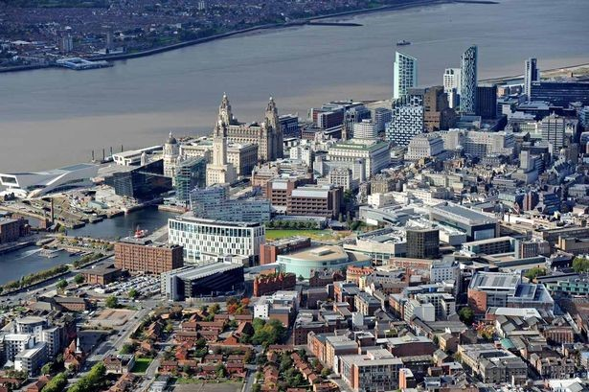
It doesn’t matter if you don’t. It’s Liverpool. I’m sure you have heard of Liverpool.
Nič hudega, če ne veš. To je Liverpool. Prepričana sem, da si že slišal/-a za Liverpool.

To name just a few things associated with Liverpool: the Beatles, Liverpool FC (a professional football club), Harry Potter and the Deathly Hallows.
Samo nekaj stvari, povezanih z Liverpoolom: the Beatles, Liverpool FC, Harry Potter and the Deathly Hallows.
Daniel Craig (the actor; “James Bond”) lived there as well. But now you will listen to Liam, a teenager, who lives there. He’ll describe Liverpool to you.
Daniel Craig (igralec; “James Bond”) je tudi živel tam. Sedaj pa boš poslušal/-a Liama, najstnika, ki živi tam. Opisal ti bo Liverpool.

So, find the enclosed mp3 Liam’s_Liverpool and, in your student’s book, on p. 154 do ex. 5a.
Tick the things in Liam’s part of the city and put a cross if the things aren’t in the part where he lives. If you have to, listen to the tape twice or three times.
Zato poišči priložen mp3 Liam’s_Liverpool in v učbeniku na str. 154 naredi nalogo 5a.
Odkljukaj stvari v Liamovem delu mesta in vstavi križec, če stvari niso v predelu, kjer živi. Če je potrebno, poslušaj posnetek dvakrat ali trikrat.

There may be a few unknown words. Make a glossary in your notebook. If there are any others, put them down as well.
Morda ti je nekaj besed neznanih. Naredi si slovarček v zvezek. Če je še katera, si jo prav tako zabeleži.

a pub – pivnica, krčma, gostilna, lokal
! a market – tržnica
(! a supermarket – samopostrežna trgovina)
a factory – tovarna

Now get your workbook and open it on p. 160. Do ex. 3a and 3b on the opposite page.
Sedaj vzemi delovni zvezek in ga odpri na str. 160. Naredi nal. 3a in 3b na naslednji strani.

There is some new vocabulary in the exercise. Write it under the glossary of the words you did previously.
V nalogi je nekaj novega besedišča. Zapiši ga pod slovarček besed, ki si ga zapisal prej.

a library – knjižnica
a department store – veleblagovnica
a railway station – železniška postaja
a petrol station – bencinska črpalka
an office building – poslovna stavba; pisarne
a car wash – avtopralnica
a bookshop – knjigarna
a sports field – športno igrišče

2. ura

First, copy the material in the box into the notebook.
Najprej prepiši snov v okvirčku v zvezek.

Prepositions of Place

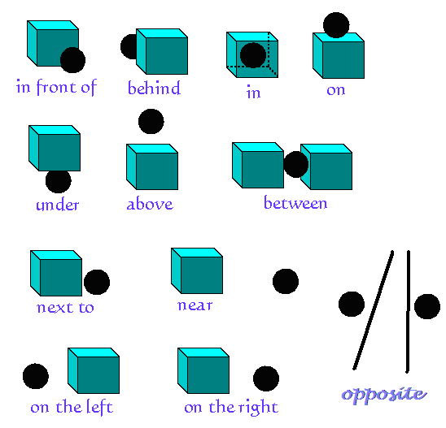

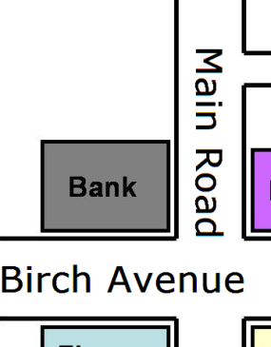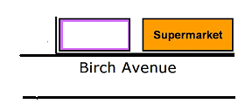

on the corner of at the end of

To continue, open your student’s book on p. 154 and do exercise 6a. Read the instructions, study the given example in your book and take a look at the example below as well.
Put down similar dialogues for the following:
- the library
- the concert hall
- the park
Put down two more dialogues of your own choice.

Nadalje, odpri učbenik na str. 154 in naredi nalogo 6a. Preberi navodilo, preuči dani primer v učbeniku in si oglej še spodnji primer.
Zapiši podobne dialoge za naslednje:
- knjižnica
- koncertna dvorana
- park
Zapiši še dva dialoga po svoji izbiri.

Example / Primer:
A: Where’s the theme park?
B: It’s in Broad Street opposite the concert hall.

To finish off today’s lesson, you will do an interactive exercise – link below. To start the tape, first click on the loudspeaker icon.
Za konec današnje ure boš naredil/-a interaktivno vajo – povezava spodaj. Da se posnetek začne, najprej klikni na ikono zvočnika.
https://quizlet.com/11224471/spell/embed/

EXTRA or WHEN BORED:
For the task, you will have to call a schoolmate.
Both need to have their student’s book. You will do ex. 6b and c on p. 155. Follow the instructions in the book and take a look at the examples.
Za naslednjo vajo boš moral/-a poklicati sošolca.
Oba potrebujeta svoj učbenik. Naredila bosta nal. 6b in c na str. 155. Sledi navodilom v učbeniku in si oglej primere.



You have successfully completed another English lesson on your own.
Uspešno si končal/-a še eno samostojno učno uro.
You don't have to send anything today.
Danes ti ni treba poslati ničesar.

Za dodatna vprašanja sva na voljo učiteljici angleščine:
- Vesna Možek Oblak: vesna.mozekoblak@ucitelj.oskm.si
- Ksenija Mrzel: ksenija.mrzel@ucitelj.oskm.si

