Rešitve 6. teden TJA 5. V in 5. H
1. URA TJA:
-VSI: DZ str. 65, nal. 1:
1. Earth
2. eight
3. sun
4. one year
5. twenty-eight days
6. bigger

-VSI: DZ str. 66, nal. 1: Dopolnite besedilo.
Sundays, has, swimming, rides
plays, homework, watches, goes

-VSI: DZ str. 66, nal. 2:
On Sundays Polly gets up at eight o'clock. She
has breakfast and does
her homewoork. After lunch, she
sometimes goes to Grandma
and Grandpa's house
and plays the piano
with Grandma. In the evening, she
reads books. She
goes to bed at eight o'clock.

-DZ str 67, nal. 1: CD 2/42:
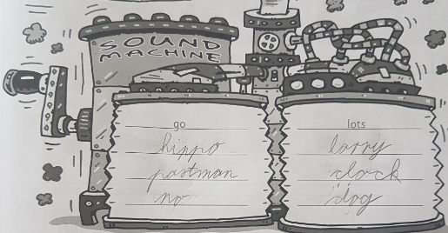

-DZ str. 67, nal. 2: CD 2/43:
Prevod (če kdo ni razumel):
Imam povodnega konja, toda nihče ne ve.
Moj povodni konj gre v tovornjaku na razstavo.
On je pametni povodni konj – je najboljši na razstavi.
On ni pes! PŠŠŠŠŠ! Toda nihče tega ne ve!

2. URA TJA:
1) VSI: Učb. str. 53: Clive, the caveman (Clive, jamski človek)
Preberite strip o Clive-u. Izpišite si ure, ko nekaj dela (v obliki tabele): Dala sem nejasna navodila, ker ste nekateri razumeli, da napišete samo tiste aktivnosti, kjer je navedena ura. Jaz sem si pa predstavljala, da boste vse aktivnosti prepisali. Nisem pomislila na to. :)

7:00 | He gets up.
?? | He has a quick shower.
?? | He gets dressed.
?? | He goes to work./ He walks to work.
?? | He paints big and small animals.
17.00 | He gets home (from work).
 | He has a big dinner.
 | He helps his daughter with her homework.
22.00 | He goes to bed.

2) VSI: učb. str. 55: Our world (Naš svet)
Za vse 4 osebe si izpišete pomembne stvari v miselni vzorec (sonček!) – pogledam vsakemu posebej.

Odgovorite na spodnja 4 vprašanja:
1 There are newspaper boys.
2 Early in the morning start jobs of the newspaper boy and a milkaman.
3 Yes, there are (na splošno mišljeno) ali drugi možni odgovor:
In the picture: No, there's only one milkman. (na sliki je samo eden)
4 A lollipop lady helps children cross the road.

3) VSI: Dz str. 68
2:15 ali 14:15
6:00 ali 18:00
5:30 ali 17:30
6:45 ali 18:45

Prva sličica (levo zgoraj): I get up at ______ (ura),
Druga sličica (desno zgoraj): I have breakfast / cereal and milk at _____ (ura).
Tretja sličica (levo spodaj): I go/walk to school at _____ (ura).
Četrta sličica (desno spodaj): I go to bed at _____ (ura).

Tvorili ste stavke:
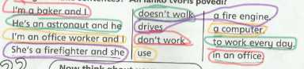

3. URA TJA:
-Prepiši si različne vrste vremena in zraven nariši. – pogledam vsakemu posebej.
-VSI: DZ. str. 70, nal. 1:
Slike zgornja vrsta: 2, 6, 3
Slike spodnja vrsta: 4, 1, 5

DZ. str. 70, nal. 2.:
Picture 1: It's cloudy.
Picture 2: It's hot and sunny.
Picture 3: It's snowing.
Picture 4: It's foggy.
Picture 5: It's raining.

-Nadstandard: Samo, kdor želi: Učb. str. 57, spodnja naloga: zapiši vprašanja o vremenu v 5 mestih ter napiši odgovore. Glej slike.
1. What's the weather like in Rio de Janeiro today? -It's cloudy.
2. What's the weather like in London today? – It's sunny.
3. What's the weather like in Moscow? -It's snowing. / It's snowy.
4. What's the weather like in New York tooday? It's raining. / It's rainy.
5. What's the weather like in Paris today? It's foggy.

-Nadstandard: Samo, kdor želi: Delovni list (spodaj):
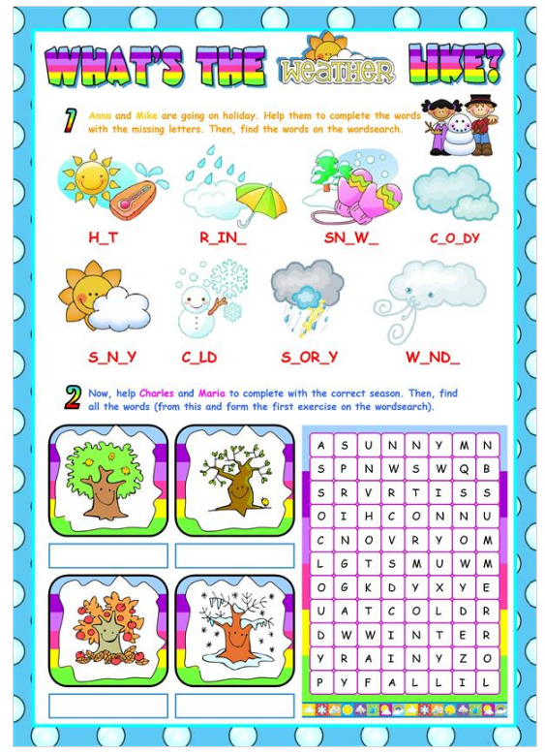
UK: AUTUMN
USA: FALL
SUMMER
SPRING
WINTER
STORMY
WINDY
COLD
SUNNY
CLOUDY
SNOWY
RAINY
HOT
Vir: https://en.islcollective.com/english-esl-worksheets/vocabulary/weather/weather-beginners-re-uploaded/10544

