MY COUNTRY
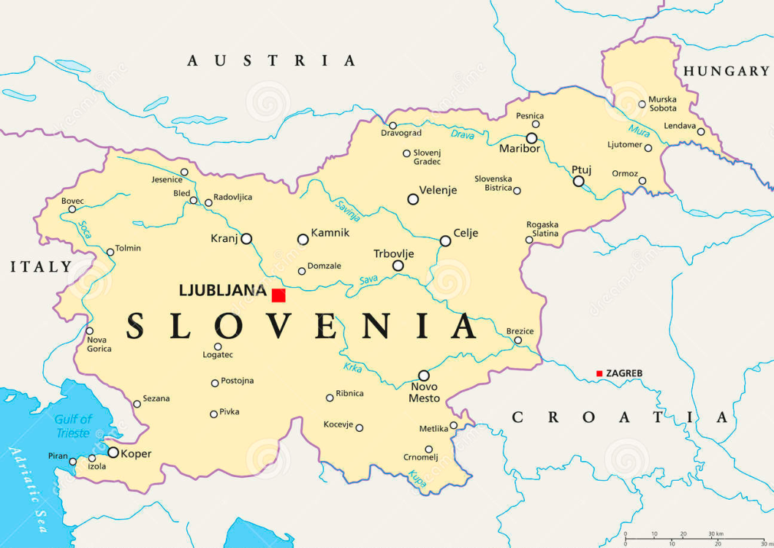

1. Fill in the missing gaps. Vstavi manjkajoče besede.
I live in ___________________ .
The capital of Slovenia is ___________________ .
The neighbouring countries of Slovenia are ___________________, ___________________, ___________________ and ___________________ .

2. Colour the Slovenian flag. Pobarvaj slovensko zastavo.
