14. 5. 2020 | TJA – 7. razred | Myths and Legends; The Giant’s Causeway 2 uri

Dear pupil,

Weekend is just round the corner – so to speak – and the sooner we get to work, the sooner we finish the lesson. If you have any questions or when troubles occur, please, contact me.

All the best to you and your family. Stay safe and sound.

Your English teacher

Spodnjo legendo že dodobra poznaš. Sam/-a se odloči, kolikšno količino nalog boš opravil/-a.

Legenda:
temno modra – rešitve nalog prejšnje ure (morajo pregledati vsi učenci)
črna – naloge morajo narediti vsi; minimalna zahtevnost
modra – naloge naredijo tisti, ki so pri pouku uspešnejši; a jih lahko delajo tudi tisti, ki si to želijo
vijolična – dodatne naloge; če si želiš več utrjevanja ali ko ti je dolgčas

Učenci,

navedene naloge pošljite v pregled v istem dnevu do 14.00 na način, ki je zabeležen v okvirčku na koncu navodil.

1. ura

First, check the exercises of the previous lesson and correct them if necessary.
Najprej preglej naloge prejšnje ure in jih po potrebi popravi.

WB p. 159/ ex. 1

1– FOUNTAIN
2 – CHURCH
3 – STATUE
4 – CASTLE
5 – MUSEUM
6 – HARBOUR
7 – HOSPITAL
8 – POST OFFICE
9 – LIBRARY
10 – FIRE STATION
11 – CAR PARK
12 – CAR WASH
13 – MARKET
14 – RAILWAY STATION
15 – PETROL STATION

WB p. 162/ ex. 5

1. between
2. in
3. opposite
4. next to
5. on the corner of
6. next to
7. opposite
8. at the end of
9. next to
10. in; opposite
11. opposite; next to

! opposite – ko se neka stvar nahaja preko ceste
! behind – ko se nekaj nahaja neposredno za nečem
WB p. 161/ ex. 4

Past Tense | Present Tense | Future Tense
 | There are many playgrounds in the town. | There will be many playgrounds in the town.
Were there enough chairs in the room? |  | Will there be enough chairs in the room?
There weren‘t any shops in the village. | There aren‘t any shops in the village.
There wasn‘t enough fresh air in the room. |  | There won‘t be enough fresh air in the room.
 | How many bridges are there in your town? | How many bridges will there be in your town?

WB p. 162/ ex.6

hotel | restaurant | cinema | post office
supermarket | museum | music shop | police station

SB p. 156/ ex. 8 (you got these answers last time, but I enclose them anyway)
1. under a tree 5. a busker 9. a café
2. a parrot 6. two 10. on the river
3. in front of the phone box 7. between the clouds 11. in the boat
4. on the bench 8. in the fountain 12. a bird

Let’s move on now.
Pa nadaljujmo.

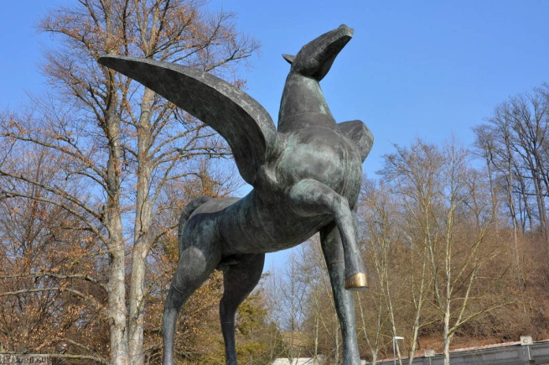
Many places, in Slovenia and worldwide, explain their origin with a myth or a legend. One of such is also Rogaška Slatina which is famous for its unique mineral water. Did you know that Greek mythology is also connected with the discovery of this exceptional well? The Greek God Apollo told the winged horse Pegasus where to strike its hoof to make the healing water run. With its discovery, Pegasus became an important part of Rogaška Slatina, as is proven by its statue in the town.

Mnogo krajev, v Sloveniji in po svetu, svoj izvor razloži z mitom ali legendo. Eden takih je tudi Rogaška Slatina, ki je znana po edinstveni mineralni vodi. Ali si vedel/-a, da je grška mitologija povezana z odkritjem tega izjemnega izvira? Grški bog Apolon je krilatemu konju Pegazu povedal, kje mora udariti s svojim kopitom, da bo pritekla zdravilna voda. Z njenim odkritjem je postal Pegaz pomemben del Rogaške Slatine, kar prikazuje tudi njegov kip v mestu.

Below are a few more places the origin of which is explained by a myth or a legend. Scientific explanation to their origin is a bit different, but there is some truth to it in every story. Take a look at them.
Spodaj je še nekaj krajev, katerih izvor je razložen z mitom ali legendo. Znanstvena razlaga je malce drugačna, vendar je v vsaki zgodbi nekaj resnice. Oglej si jih.

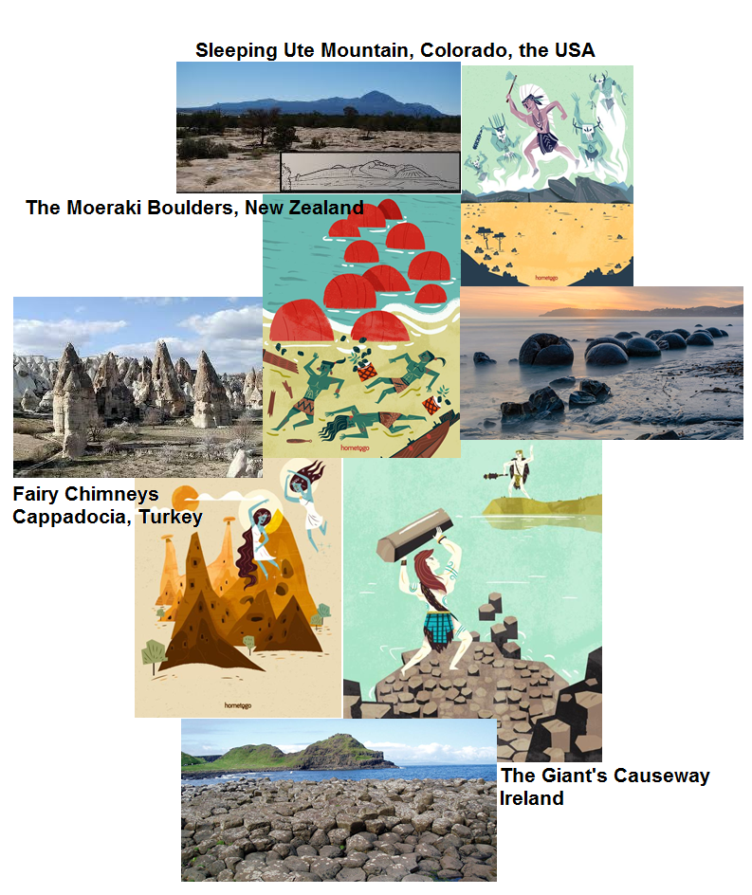

Now that you have taken a look at the pictures, get your notebook and put down the title Myths and Legends. If you have the opportunity, glue the pictures above into your notebook – don’t worry if you don’t. Now answer the questions below in full sentences in your notebook.
Ko si si ogledal/-a slike, vzemi zvezek in zapiši naslov Myths and Legends. Če imaš možnost, zgornje slike prilepi v zvezek – ne skrbi, če ne moreš. Sedaj odgovori na spodnja vprašanja v celih stavkih. Odgovore zapiši v zvezek.

- How many places are represented by the pictures?
- Name the places. Where are they?
- Pick one place and make up a story of its origin. Take a look at the drawing because it retells the story. (Don’t search the web, make it up! (Ne brskaj po spletu, izmisli si!))

2. ura

In this part of the lesson, you will find out how the Giant’s Causeway was created.
V tem delu ure boš spoznal/-a, kako je nastal Velikanov prehod.

So find the enclosed pdf Finn MacCool first. Print it and glue it into your notebook. If you can’t print it, just read it from the computer and put down the answers into your notebook.
Zato najprej poišči priložen pdf Finn MacCool. Natisni list in ga prilepi v zvezek. Če ga ne moreš natisniti, beri z računalnika, odgovore pa zapiši v zvezek.

Now read the text and while reading, underline the words you don’t understand.
Sedaj preberi besedilo in med branjem podčrtaj neznane besede.

In your notebook put down the title Finn MacCool and the Giant’s Causeway. In the text, find the words for the given Slovene translations in the box below and put down the glossary in the notebook.
V zvezek zapiši naslov Finn MacCool and the Giant’s Causeway. V besedilu poišči besede za dane slovenske prevode v spodnjem okvirčku in zapiši slovarček v zvezek.

čudo; čudež hladiti; ohladiti se izvleči/ izpuliti legenda
mit mogočen, močan oblika ogromen, gromozanski
površina potisniti skrivnosten sovražnik velikan
vrel/-a/-o vulkanski izbruh zamisliti si, zamišljati si znanost

If necessary, use the online dictionary:
Po potrebi uporabi spletni slovar:

https://sl.pons.com/prevod

Now do exercises 2 and 3 on the worksheet.
Sedaj naredi nalogi 2 in 3 na učnem listu..
Imagine you went to Ireland and you visited the Giant’s Causeway. Write an email to your English-speaking friend in about 80 words. Include the following cues:
Zamisli si, da si šel/šla na Irsko in obiskal/-a Velikanov prehod. Svojemu angleško-govorečemu prijatelju napiši e-sporočilo v približno 80 besedah. Vključi naslednje iztočnice:

- where you were, when you were there, who you went with
- what it looked like
- what the legend says about its origin
- how you felt/ what you thought.

This is it. Have a nice day.



You have successfully completed another English lesson on your own.
Uspešno si končal/-a še eno samostojno učno uro.

V. Možek Oblak: scan or take a photo of the answers to Myths and Legends, the
glossary of Finn MacCool (and the e-mail to your friend)
and e-mail them to me, please.
Prosim, skeniraj ali fotografiraj odgovore na Myths and Legends, slovarček Finn MacCool (in e-sporočilo svojemu prijatelju) in mi ga pošlji po e-pošti.

K. Mrzel: scan or take a photo of the answers to Myths and Legends, the
glossary of Finn MacCool (and the e-mail to your friend)
and upload them in Peskovniki - Moodle course TJA7 – Oddaja zadolžitev
– Naloga 14. 5. 2020, please.
You have to log in first (username: ime_priimek; password: the last three numbers of EMŠO) to be able to see the Moodle course.
Prosim, skeniraj ali fotografiraj odgovore na Myths and Legends, slovarček Finn MacCool (in e-sporočilo svojemu prijatelju) in ga naloži v Peskovniki - spletna učilnica TJA7
– Oddaja zadolžitev – Naloga 14. 5. 2020.
Najprej se moraš prijaviti (uporabniško ime: ime_priimek; geslo: zadnje tri številke EMŠO), da lahko vidiš spletno učilnico.

Za dodatna vprašanja sva na voljo učiteljici angleščine:
- Vesna Možek Oblak: vesna.mozekoblak@ucitelj.oskm.si
- Ksenija Mrzel: ksenija.mrzel@ucitelj.oskm.si

