Rešitve za 7. teden TJA 4. V in 4. H
1. URA:
VSI: DZ str. 70, nal. 1:
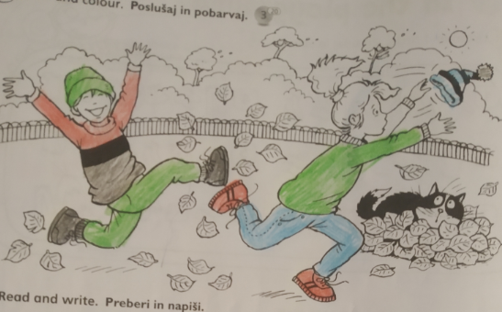

-VSI: spodnja naloga: Pojdi z različnimi barvicami po vrvicah in potem napiši, čigavi so narisani predmeti.
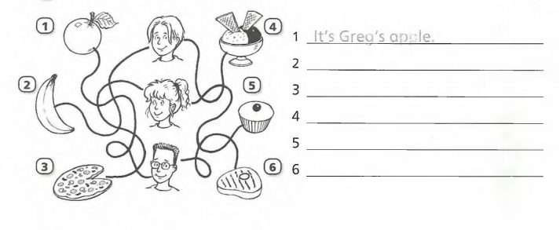
It's Greg's steak.
It's Polly's cake / cupcake.
It's Jack's ice cream.
It's Polly's pizza.
It's Jack's banana.
-NADSTANDARD, SAMO, KDOR ŽELI: DZ. str. 71; Quizzy
1. It's Quizz'y shoe!
2. And this is Quizzy's jumper!
3. Where's Quizzy?
4. Hello! I'm here!
-NADSTANDARD, SAMO, KDOR ŽELI: Delovni list: Napiši, čigavi so predmeti.
Npr. It's Mother's sewing machine.
It's Curt's football.
It's Jenny's book. It's Jenny's bow.
It's Father's UK Atlas / UK atlas.
It's Mother's bag.
It's Lizzy's Tutu.
It's David'y octopus/Octopus.
It's Ronny's heart toy/ Heart toy.
OR: It's Mother and Father's heart toy.
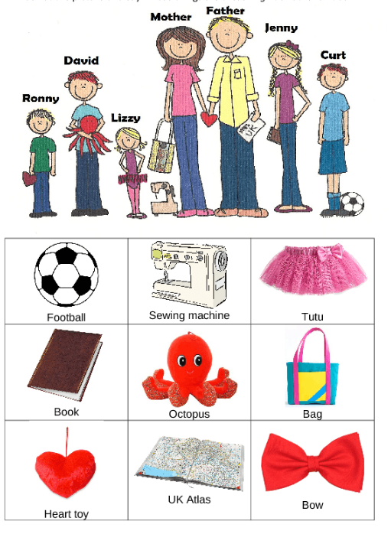

2. URA:
DZ str. 72, nal. 1: Poslušaj CD 3/22 in obkroži A ali B
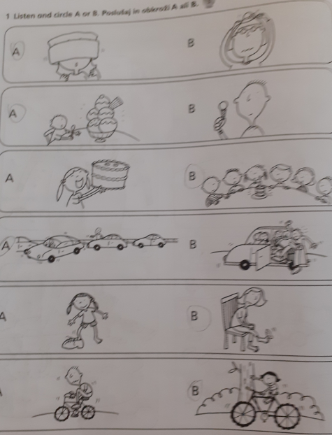

DZ str. 73, 2. nal.:
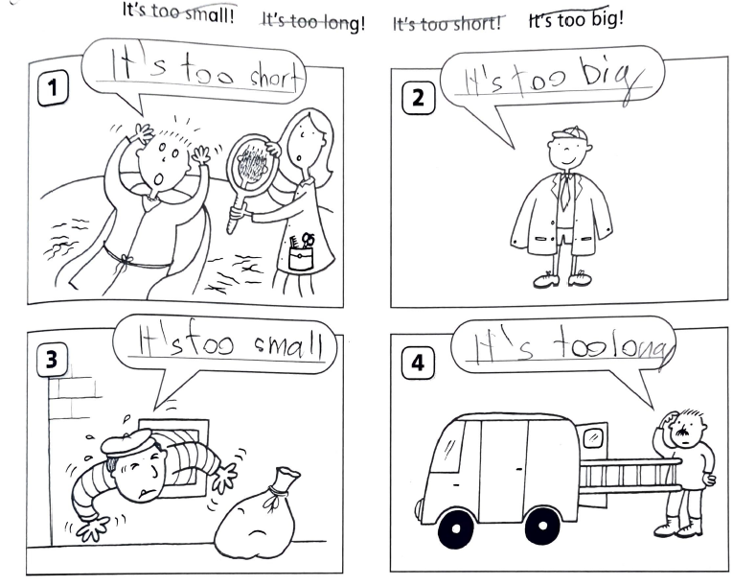
Stavke v zvezku pregledam vsakemu posebej.

