

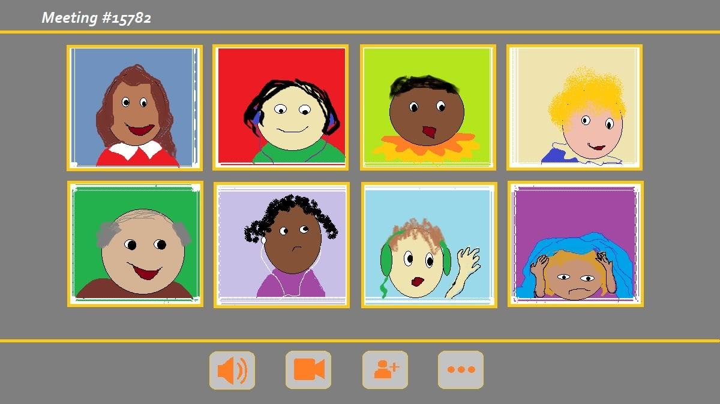

You are invited to a ZOOM meeting:
CLASS | DATE | HOUR
4. A | Friday,  8th May  2020 | 9.00
4. B | Friday,  8th May  2020 | 10.00
4. C | Friday,  8th May  2020 | 11.00
4. D | Friday,  8th May  2020 | 12.00

Personal invitation was sent to your parents' email account.

