Zadolžitve za 9. teden (25. 5. – 29. 5. 2020) TJA 5. H in 5. V

1. URA:
Utrjevanje: Opisni sedanjik. (Podobno kot članek o taborjenju učb. str. 61)
Write about an adventure in the mountains. Look at the picutres and write what is going on. What are the parents and the children doing? What animals are there? What about the stream/river/flood etc. Write at least 3 sentences for each picture. Piši o pustolovščini v gorah. Oglej si slike in napiši, kaj se dogaja. Kaj delajo starši in otroci? Katere živali so tam? Kaj pa potoček/reka/poplava? Napiši vsaj 3 stavke ob vsaki sličici.

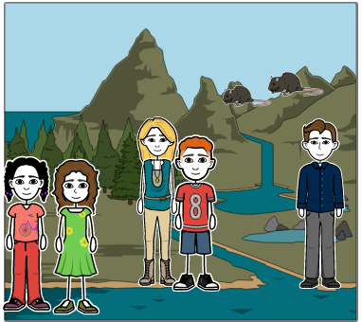

________________________________________________________________________________________________________________________________________________________________________________________________________________________________________________________________________________________

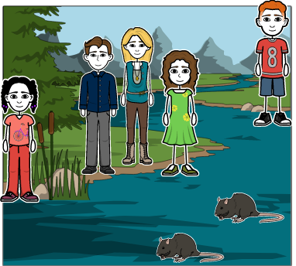_______________________________________________________________________________________________________________________________________________________________________________________________________________________________________________________________________________________________________________________________________________________________________

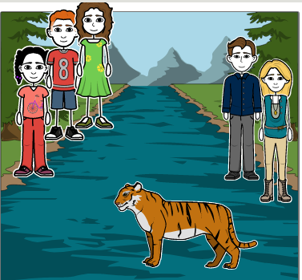
________________________________________________________________________________________________________________________________________________________________________________________________________________________________________________
2. URA: VSI: Reši spodnje naloge za utrjevanje snovi.

1) What are they doing? (Kaj počnejo?) Pomagaj si z besedami iz tabele.
PLAY BASKETBALL DANCE ROLLERBLADE PLAY CHESS DO HOMEWORK

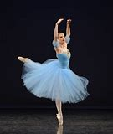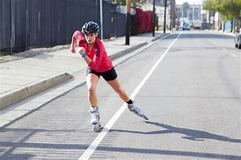

- 1 2 3 4

0 _____He is playing basketball.__________________________________________________

1 ___________________________________________________________________________

2 ___________________________________________________________________________

3 ___________________________________________________________________________

4 ___________________________________________________________________________

2) What's the weather like? Kakšno je vreme? Zapiši povedi.

1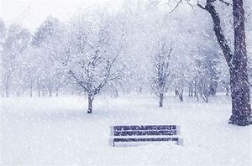 2 3 4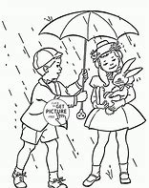 5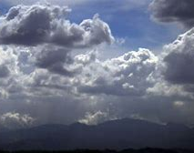 6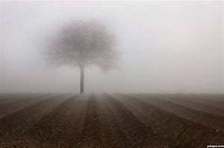

1.It's ________________ 2._____________________ 3._____________________

4._____________________ 5._____________________ 6._____________________

3) This is Tim's room. Write 7 sentences. To je Timova soba. Napiši 7 povedi o njem.


1.Tim likes _____________________
2. He plays _____________________
3.He's got _____________________
4. He ___________________________________________
5. _____________________________________________
6. _____________________________________________
7. _____________________________________________

8 4) READ THE TEXT. WRITE TRUE (T) OR FALSE (F).
Pr a) Preberi besedilo in ZAPIŠI – T pravilno ali F narobe.

My name is Henry. I'm 18 years old. I come from New York. I've got a brother. His name is Ted. He's fifteen. We live in a terraced house. Our house isn't very big but I've got my room. I like reading but I don't like watching TV. I play tennis and I collect stamps. I speak English and Spanish.

- Henry is from the USA. ________
- He's got a sister. ________
- He lives in a big flat. ________
- His room is very small. ________
- He doesn't like computer games. ________

8.

4. b) NOW ANSWER THE QUESTIONS IN SHORT. Odgovori na vprašanja na kratko.

1. How old is Henry? ____________________________________________________
2. Is Ted older than Henry? ____________________________________________________
3. What sports does Henry play/do? ____________________________________________________
4. Does he collect shells? ____________________________________________________
5. Does he speak Slovene? ____________________________________________________

3. URA:
VSI: Učb. str. 63:
-Poslušaj CD 3 / 9, kjer pripovedujejo o športih oz. prostočasnih dejavnostih, ki so značilni za določene dele Združenega kraljestva (the UK). Besedilo opisuje, kaj športniki na slikah delajo v tem trenutku, zato je uporabljen Present Continuous Tense (Opisni sedanjik).
VSI: Naredi si miselni vzorec za vse 4 športe. Nato odgovori na vprašanja pod besedilom.
VSI: Na podoben način opiši, kateri športi so značilni za Slovenijo. Če je kak šport še posebej značilen za katero pokrajino ali kraj, napiši ime te pokrajine, sicer pa lahko napišeš nasploh. Ali pa napišeš npr., da je plezanje značilno za gore.
-Napiši vsaj 5-10 stavkov.

NADSTANDARD: DZ str. 77, nal. 1 in 2.

NADSTANDARD: Oglej si video o športih v UK. Tudi če ne boš razumel/-a vsega besedila, boš zagotovo ujel/-a imena prikazanih športov. Pri zadnjem (imenuje se parkour) je še posebno opozorilo, da tega NE poskušajte izvajat vi sami doma, ker je smrtno nevarno.
-Zapiši omenjene športe v zvezek.
https://www.youtube.com/watch?v=is1TnRNVJFc

