28. 5. 2020 | TJA – 6. razred | Modal Verbs: Must and Should; Health Problems  2 uri

Dear pupil,

Distance education continues but maybe not for too long. So let’s just get to work. If you have any questions or when troubles occur, please, contact me.

All the best to you and your family. Stay safe and sound.

Your English teacher

Spodnjo legendo že dodobra poznaš. Sam/-a se odloči, kolikšno količino nalog boš opravil/-a.

Legenda:
temno modra – rešitve nalog prejšnje ure (morajo pregledati vsi učenci)
črna – naloge morajo narediti vsi; minimalna zahtevnost
modra – naloge naredijo tisti, ki so pri pouku uspešnejši; a jih lahko delajo tudi tisti, ki si to želijo
vijolična – dodatne naloge; če si želiš več utrjevanja ali ko ti je dolgčas

Učenci,

sedaj že veste, da morate navodila pozorno brati in se jih držati. Tudi pravila glede oddajanja nalog poznate.

1. ura

First check the exercises of the Thursday’s lesson.
Najprej preveri naloge četrtkove ure.

WB p. 147/ ex. 15

1 Jane has got a cold / a runny nose.
2 Tim has got a cough.
3 David has got an earache.
4 Bill has got a fever / a temperature.
5 Jack has got a backache / a sore back.
6 Julie has got a headache.
7 Bob has got a sore throat.
8 Gary has got a stomach-ache.
9 Caroline has got toothache.
10 Mathew has got flu.
11 Rose has got a pain in her knee. / Rose's knee hurts. / Her knee hurts.

WB p. 140/ ex. 1

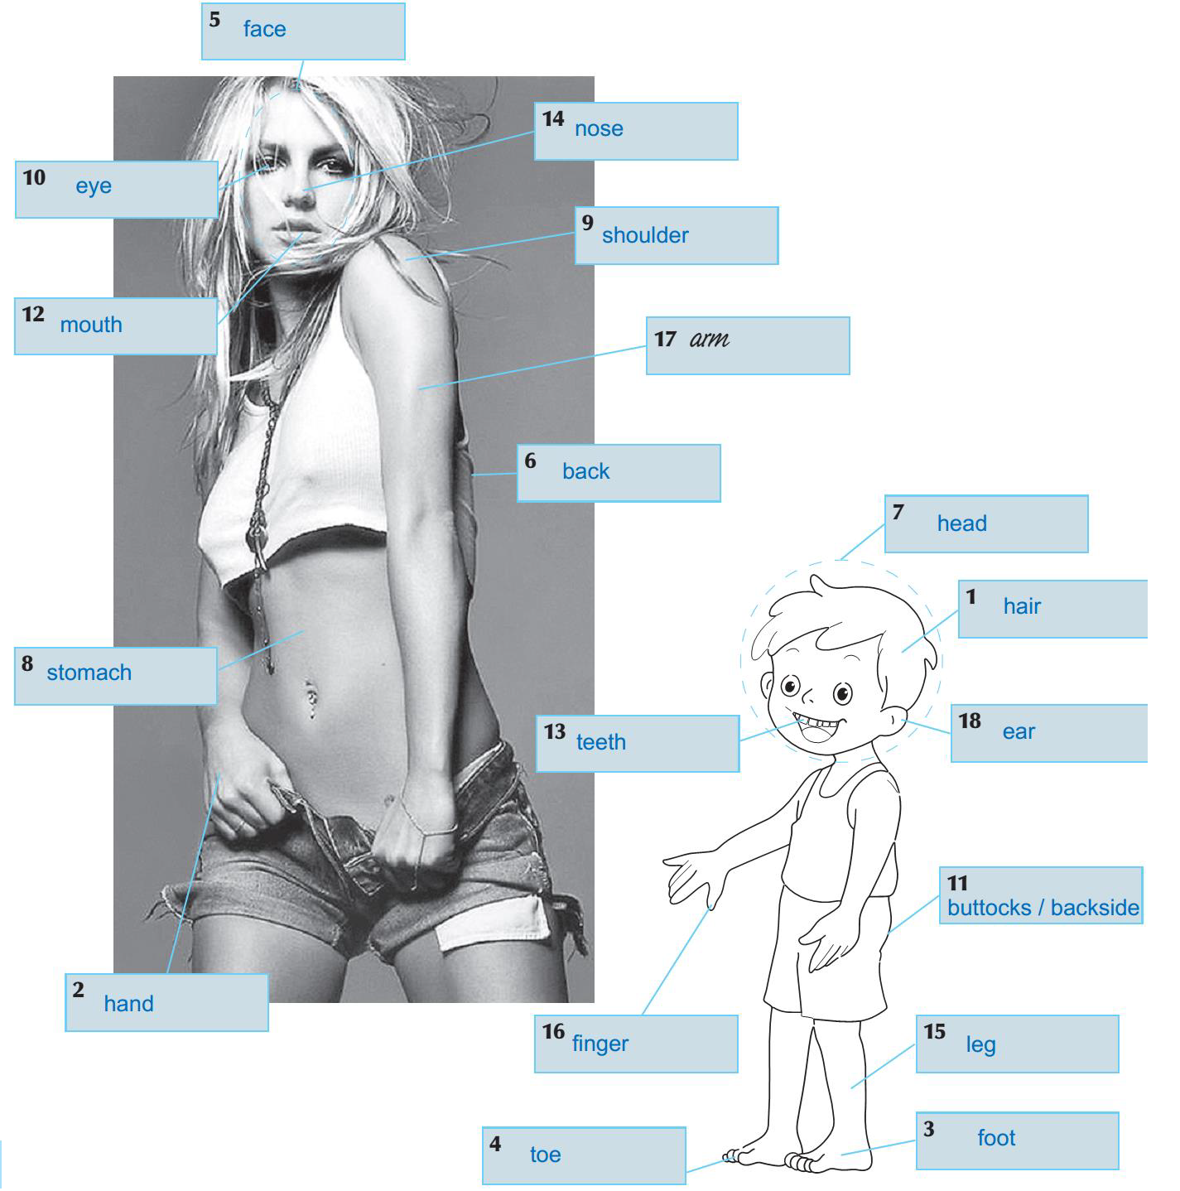

Let’s do an exercise in the workbook first: p. 116/ ex. 27.
Najprej naredimo vajo v delovnem zvezku: str. 116/ nal. 27.

Now open your student’s book on page 149. Copy the link below in your browser and then listen and read the dialogues at exercise 4a.
Sedaj odpri učbenik na strani 149. Kopiraj spodnjo povezavo v spletni brskalnik, nato pa poslušaj in beri dialoga v nalogi 4a.

http://e-gradiva.com/dokumenti/T6/eT6/T6-5_datoteke/A173.webm

I believe there is no new vocabulary, but if that’s not the case, use the dictionary.
Menim, da ni novega besedišča. Če temu ni tako, uporabi slovar.

http://www.e-gradiva.com/dokumenti/T6/T6/SLOVAR.pdf
In the two dialogues, there are two new modal verbs. Some time ago, you came across the modal verb can and now you will learn about should and must.
V teh dveh pogovorih sta dva nova modalna/ naklonska glagola. Pred časom si spoznal/-a modalni glagol can, sedaj pa se boš učil/-a o should in must.

That is why copy the material in the box into your notebook.
Zato dano snov prepiši v zvezek.

Modal Verbs: must and should
Naklonski glagoli: must in should

MUST/ MUSTN'T IZRAŽA DOLŽNOST/ OBVEZNOST. Povemo, kaj nekdo mora oz. česa ne sme storiti.

You must listen to your parents.
You mustn't come to class late.

SHOULD/ SHOULDN'T IZRAŽA NASVET/ PREDLOG. Povemo, kaj bi nekdo moral oz. česa ne bi smel storiti.

You should do the exercises carefully.
You shouldn't eat too many sweets.

Poleg modalnega glagola za izražanje nasvetov oziroma podajanje predlogov uporabljamo strukturi »let's« in »why don't you/ we«:

Let's go to the zoo. / Why don't we go to the zoo?
Why don't you make yourself a sandwich?

Continue in your student’s book on page 150. At ex. 4b there is chart about health problems. Study it and if there are any words you don’t understand, look them up in the dictionaries (links below) and make a glossary in the notebook.
Z delom nadaljuj v učbeniku na strani 150. Pri nal. 4b je razpredelnica o zdravstvenih težavah. Preuči jo in če je kaka neznana beseda, jo poišči v slovarjih (povezavi spodaj), v zvezek pa si naredi slovarček.

http://www.e-gradiva.com/dokumenti/T6/T6/SLOVAR.pdf
https://sl.pons.com/prevod

2. ura

You will start the lesson by going back to page 150 in your student’s book. Take a look at the example below the chart in ex. 4b and put down 3 / 5 similar dialogues into your notebook. Use the ideas in the chart, but yours are welcome as well. The title is Health Problems.
Uro boš začel/-a tako, da se vrneš na str. 150 v učbeniku. Oglej si dani primer pod razpredelnico v nal. 4b in zapiši 3 / 5 podobnih dialogov v svoj zvezek. Uporabi ideje v razpredelnici, tvoje pa so tudi dobrodošle. Naslov je Health Problems.

We started today’s lesson with a revision and we’re finishing it with a revision. Get your workbook and do the following exercises:
p. 113/ ex. 20
p. 127/ ex. 49
Današnjo uro smo začeli z utrjevanjem snovi, pa jo še končajo z utrjevanjem. Vzemi delovni zvezek in naredi naslednji nalogi:
str. 113/ nal. 20
str. 127/ nal. 49

This is it for the week. Have a nice day.
To je vse za ta teden. Lep dan ti želim.

EXTRA:
Body parts:
https://www.montsemorales.com/vocabulario/body1.htm

Health problems:
http://jerome.boulinguez.free.fr/english/file/hotpotatoes/whatswrong.htm

You have successfully completed another English lesson on your own.
Uspešno si končal/-a še eno samostojno učno uro.

V. Možek Oblak: scan or take a photo of the the dialogues in your notebook
(Health Problems) and e-mail them to me, please.
Prosim, skeniraj ali fotografiraj dialoge v učbeniku (Health Problems) in mi jih pošlji po e-pošti.

K. Mrzel: scan or take a photo of the the dialogues in your notebook (Health
Problems) and upload them in Peskovniki – Moodle course TJA6 –
Oddaja zadolžitev – Naloga 28. 5. 2020, please.
You have to log in first (username: ime_priimek; password: the last three numbers of EMŠO).
Prosim, skeniraj ali fotografiraj dialoge v učbeniku (Health Problems) in jih naloži v: Peskovniki – spletna učilnica TJA6 – Oddaja zadolžitev – Naloga 28. 5. 2020.
Najprej se moraš prijaviti (uporabniško ime: ime_priimek; geslo: zadnje tri številke EMŠO).

Za dodatna vprašanja sva na voljo učiteljici angleščine:
- Vesna Možek Oblak: vesna.mozekoblak@ucitelj.oskm.si
- Ksenija Mrzel: ksenija.mrzel@ucitelj.oskm.si

