- Listen and write the number you hear. / Poslušaj in napiši številko, ki jo slišiš. ___/4
a) |  |  | c)
b) |  |  | d)

- WINNIE'S SONG. Listen and put the text in the right order. / Poslušaj in označi pravilni vrstni red. ___/5
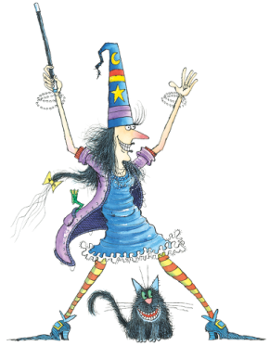
Ten long toes,
 | A long red nose.
1 | A big tall hat,
 | Winnie the witch.
 | She's Winnie,
 | A black magic wand,

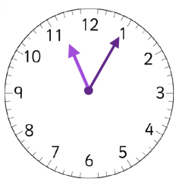
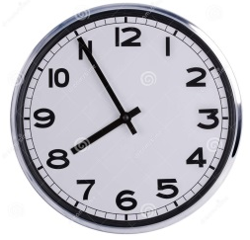
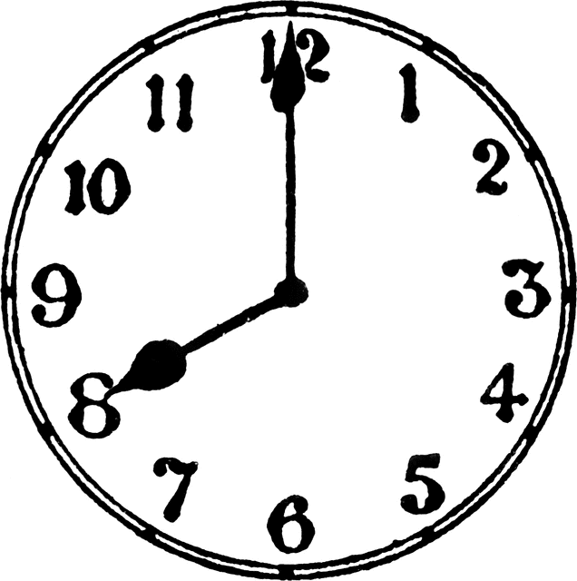
- WHAT'S THE TIME? Choose the right answer. / KOLIKO JE URA? Izberi pravilni odgovor. ___/3

a) | It's five to eight. |  | d) | It's five to eleven.
b) | It's eight o' clock. |  | e) | It's five past eleven.
c) | It's five past eight.

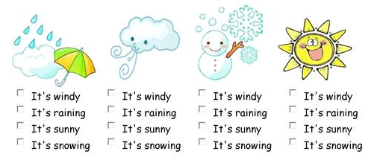
- What's the weather like? Tick. / VREME.Okljukaj pravilni odgovor. ___/4

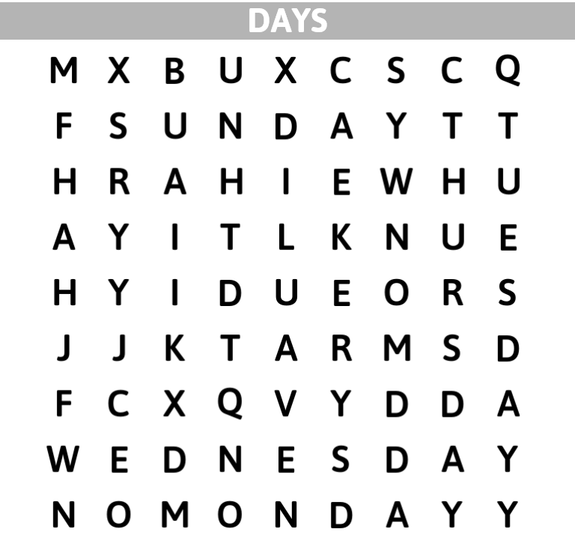
- DAYS OF THE WEEK. Word search. / DNEVI V TEDNU. Poišči jih. ___/7

- BODY PARTS. Write./ DELI TELESA. Dopiši. ___/8

hand | leg | eyes | ears
head | arm | mouth | foot
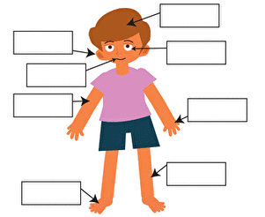

- THIS IS ME. Fill in the gaps. / TO SEM JAZ. Dopolni. ___/5

My name is _______________.
I am ______________ years old.
My birthday is in ________________.
My hobby is __________________.
I like ________________.

- WINNIE COULD FLY AGAIN. Copy the sentences. / Pravilno prepiši povedi. ___/8

Winnie and her cat Wilbur flew on the broom.
One day the sky was very busy and Winnie crashed into a helicopter a hang glider and a high building. Winnie had enough. She took her black magic wand and turned her broom into a bicycle.
________________________________________________________________________________________________________________________________________________________________________________________________________________________________________________________________________________________________________________________________________________________________________________________________________________________________________________________________________________________________
- THE SNAIL AND THE WHALE. Choose the right word. / Izberi pravilno besedo. ___/5

foot tail snail whale world
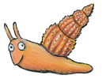
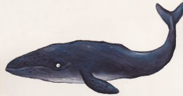
This is a tale of a tiny ________________
and a great big humpback whale _____________.
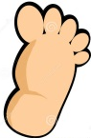

The snail has an itchy ______________
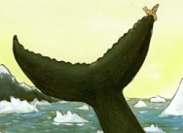
and wants to travel around the _______________.
Then comes a whale with its ____________.

- ROOM ON THE BROOM. Write the sentences. / Zapiši povedi. ___/6
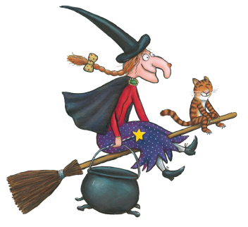
- A witch / on the broom/ and a cat / flew.
_________________________________________________
- the hat / A dog / found
_________________________________________________
- was / hungry / The dragon
_________________________________________________

VREDNOTENJE:
Kriterij: 0-27=1 28-34=2 35-41=3 42-48=4 49-55=5
7.naloga: Točka se prizna, če je besedilo smiselno dopolnjeno. Pravopisne napake se ne upoštevajo.
8.naloga: Za vsako napako se odšteje pol točke.
10.naloga: Ena točka se prizna za pravilen vrstni red in ena za pravilen prepis.

