Zadolžitve za 9. teden (25. 5. – 29. 5. 2020) TJA 4. H in 4. V

1. URA: Utrjevanje.
1) Preberi in pobarvaj glede na opis v besedilu. NAD osebe napiši njihova imena.
JILL TOM Jane
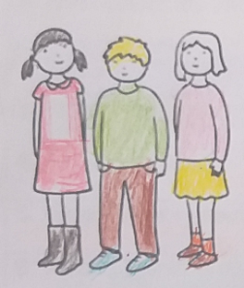

2. Kaj znaš? Česa ne znaš? Zapiši 6 stavkov. Uporabi CAN oz. CAN'T.
(Glagoli v pomoč: dive = skakati v vodo, ski, play tennis, swim, ride a bike, play football)
To bom pogledala vsakemu posebej, ko mi pošljete.

3. Preberi in poveži z različnimi barvicami. Lahko pobarvaš obe polovici.

1. What colour are Jack's shoes? | a. It's brown.
2. Is Ali a man? | b. It's Jack's.
3. What's your favourite food? | c. Yes, I can.
4. Are you a baby? | d. It's in the bedroom.
5. What colour is Ann's hair? | e. No, she's a woman.
6. Whose T-shirt is on the chair? | f. Pasta.
7. Where's your kite? | g. No, I'm not.
8. Can you ski? | h. They're black.

4. Ustrezno poveži z različnimi barvami.

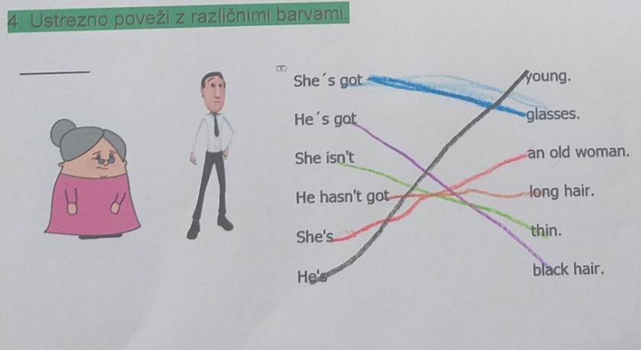

5. Read the text about Bill and gap fill the missing words. Use right words from the box.
Bill's a ¹_boy__ from the UK. He ²_isn't__ a man. He ³_is__ only ten years old . He's very ⁴_tall_ - 155 cm and thin. He's got ⁵__short__ ⁶ __ginger_ hair and blue ⁷__eyes__ . His feet are ⁸_big__, size 40. He ⁹_can__ play basketball very well. He plays in a local basketball club. But he ¹⁰__can't__ play football. Nobody's perfect.

6. Poglej, preberi in dopolni z nekaterimi besedami iz okvirčka


Tom is a ¹__young__ ²__boy__. He's eight years ³__old__. He's got ⁴_short___ ⁵_brown__ hair and brown eyes. He ⁶_hasn't got__ glasses. He isn't very ⁷_short__ - 115 cm. He ⁸__is__ thin.

2. URA:
Učb. str. 63, Brownies and Cubs - Odgovorite na vprašanja pod besedilom.
1. Yes.
2. Yes.
3. Yes/No. (odvisno od učenca, najbrž večina ni)

NADSTANDARD:
-Oglej si slike uniform litijskih skavtov in jih opiši:
A green, blue and white scoutscarf, an orange-brown shirt, jeans or blue shorts, socks, shoes...
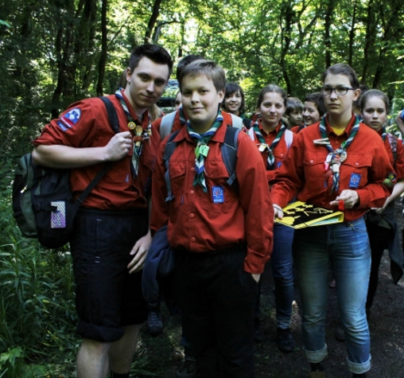

NADSTANDARD: ... lahko pa napišeš oz. narišeš aktivnosti, s katerimi se ukvarjajo.
Če ste tukaj kaj napisali, si obkljukajte, če niste, lahko spodaj pogledate aktivnosti. Načrtno nisem napisala slovenskega pomena besed, da bi vas spodbudila, da besedo vtipkate v google ter izberete slike, ter smai pogledate pomen, kjer vam bo takoj vse jasno. Tako se največ naučite. :)

Activities:
Archery, cycling / riding a bike / mountain biking, climbing, abseiling
rowing / rafting / kayking, canoeing, fencing,
flying in a (sports) plane,
mountaineering / hiking, canyoning, caving,
sailing, hovercrafting, scuba diving, raft building, windsurfing, hang gliding, microlighting,
dragon boating, 4-wheel driving / quadbiking, parasending, lawn water sliding,

making music / playing the guitar, playing games / football, walking on a rope, team games, campaigning, cutting wood, making a fire, grilling Marshmallows, knot tying, theatre, volunteering, travelling/backpacking etc.

