5th grade: REVISION OF THEMES IN UNIT 4: FOOD AND DRINK
READ THE NINSTRUCTIONS CAREFULLY. WISH YOU ALL THE BEST. 

- WRITE (=napiši)…

- …10 words for FRUIT

- …10 words for VEGETABLES

- …5 words for DESSERTS

- …5 words for FOOD WE EAT FOR BREAKFAST, LUNCH and DINNER
breakfast | lunch | dinner

- …10 words for DRINKS

- Write all the days of the week (=zapiši vse dneve v tednu)

- Answer these questions (=odgovori na naslednja vprašanja v celih stavkih).
What do you like eating for breakfast?
What is your favourite food?
What does your mum eat for dinner?
Do you like fish?
Does your dad like ice-cream?

- Look at the pictures and write what Peter likes and what he doesn't like (=poglej slike in zapiši, kaj Peter rad je in česa ne mara).
LIKES |   This is Peter. | 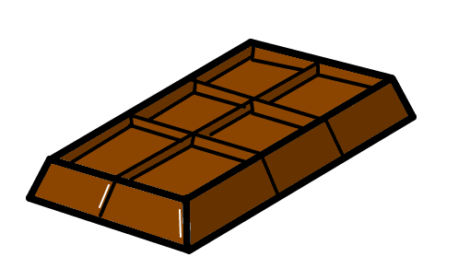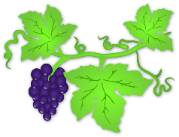  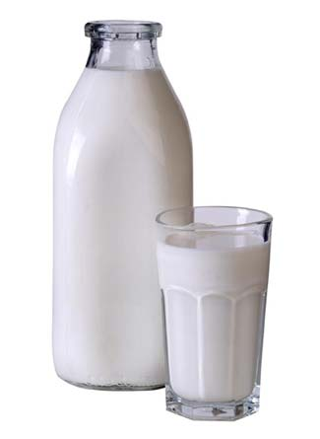DOESN'T LIKE

1 | Peter likes hot-dogs.
2
3
4 | Peter doesn't like chocolate.
5
6

- Translate these sentences in English or Slovene (=naslednje stavke prevedi v angleščino ali slovenščino).
We eat salad with a fork. |  | Mi jemo juho z žlico.
We fry pancakes in a pan. |  | Mi pijemo čaj iz skodelice.
We put food on a plate. |  | Mi uporabljamo nož, da narežemo kruh.

- Match the two halves of the expressions (=poveži oba dela izrazov).
1 | To cut |  | the food
2 | To serve |  | with honey
3 | To add |  | an apple
4 | To spread |  | some sugar
5 | To heat |  | the oven

Now translate these expressions (=sedaj te izraze prevedi v slovenščino).
1
2
3
4
5

- Circle the correct words (=obkroži pravilno besedo).

- CUT/PUT the apples and POUR/SERVE some drops of lemon juice on them. SPREAD/ PEEL them with honey and SPRINKLE/HEAT some coconut flour over them.
- CUT/PUT different fruit on sticks. WASH/SERVE with some vanilla yoghurt.
- ADD/SPREAD pizza, tortilla or bread with yoghurt. HEAT/PUT on small pieces of any fruit you like.
- PEEL/WASH the bananas and CUT/POUR them into small pieces. SPREAD/ADD them with chocolate or almond yoghurt.

- Complete the text. Use the words in the box (=dopolni besedilo. Uporabi besede v okvirju).

angry cook decides delicious dinner is know leg one parties river your

Thre lives a king who loves ______________________. Every Saturday he invites lots of friends and every Saturday the cook cooks a delicious _________________. One day the king orders the cook to make a nice dinner. The cook doesn't ____________________what to cook.
He thinks for a while and then he ________________to roast a stork. It smells good and the cook decides to taste it. It is _________________________. He thinks noone will notice that ______________________leg is missing.
But he is wrong. The king notices it and is very _________________at the cook. The cook invites the king to come to the ____________________ with him. There are many storks there, all standing on one __________________. The king claps and the birds fly away showing their two legs. The cook still doesn't want to tell the truth so he says to the king:« __________Majesty, you didn't clap last night.«

- Use the information and write sentences (=uporabi informacije in napiši stavke; glej primer).
 | love | like | Don't mind | Don't like | hate
Susan | cheese |  |  | butter
Peter |  | grapes | bananas
Tom | chicken |  |  |  | pasta

Susan loves cheese but she doesn't like butter.
Peter
Tom

- Write what time it is (=napiši, koliko je ura)?
