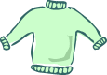
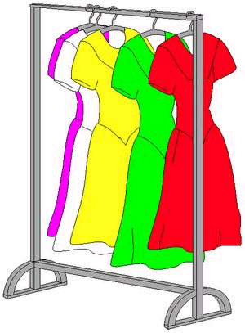
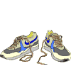
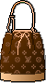
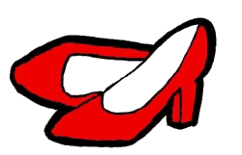
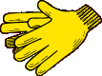
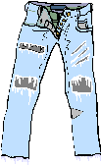
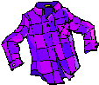
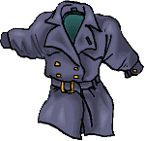
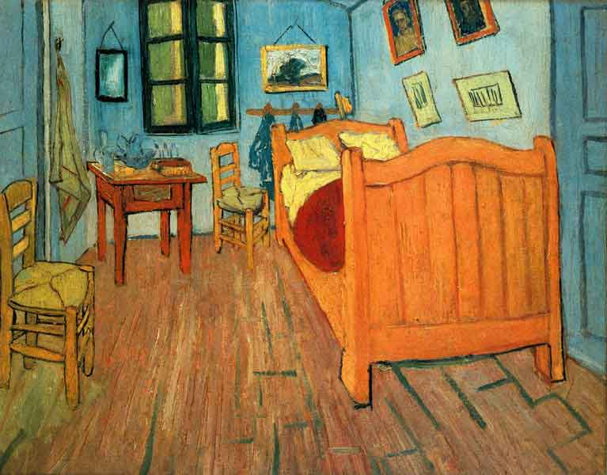
2
14
13
12
11
10
6
7
5
3
4
9
1
8

1 shirt – 2 dress – 3 shoes – 4 skirt – 5 boots – 6 umbrella – 7 bag – 8 gloves – 9 trousers
10 hat – 11 socks – 12 coat – 13 trainers – 14 sweater

Where are the clothes?

Describe the scene using opposite – on – under – in front of – behind – between – next to
Example: The gloves are under the chair.

