HOUSEHOLD CHORES (HIŠNA OPRAVILA)
/haushould čors/
Write down into your notebook the household chores you do. Write also how often you do them. Example:
I sometimes cook simple foods.
I always take the rubbish out.

make my bed | 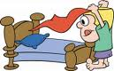
pick up toys | 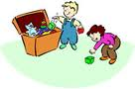
hang clothes on hooks | 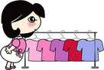
feed the animals | 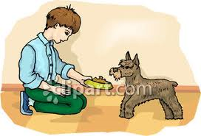
bring in the newspaper | 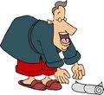
mop | 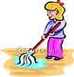
take care of pets | 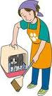
cook simple foods | 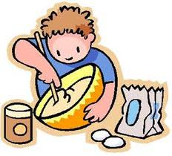
wash the car | 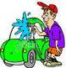
vacuum and sweep /swip/ | 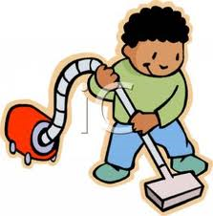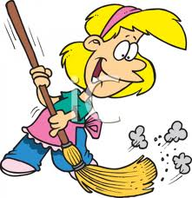
clean the bathroom | 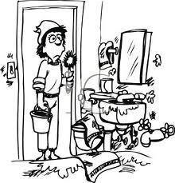
rake /reyk/ leaves | 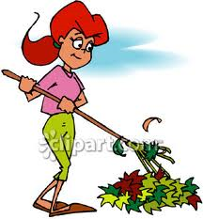
shovel /šawl/ snow | 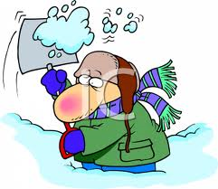
hang laundry | 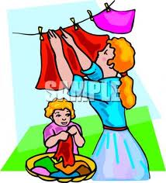
clear dishes from the table | 
set the table | 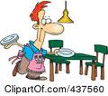
retrieve the mail | 
take the rubbish out | 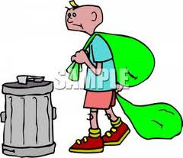
dust the furniture | 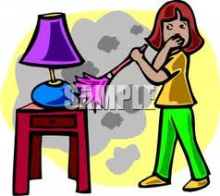
help in the kitchen | 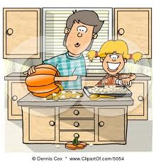
change light bulbs | 
prepare a meal | 
mow /mou/ the lawn | 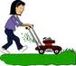
wash up | 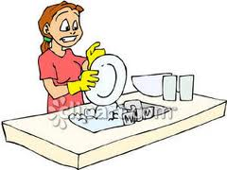
make grocery lists and do the shopping | 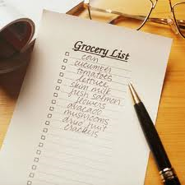
tidy my room | 