ČIGAVO JE KAJ?
TINA | 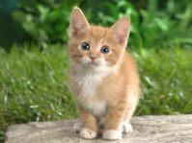 | _______________________
STRIC | 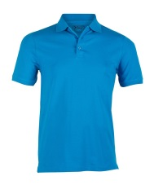 | _______________________
MAMA | 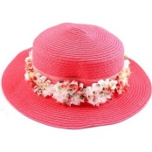 | _______________________
DEDEK | 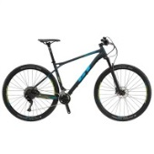 | ______________________
LARA | 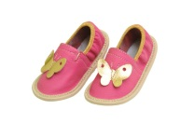 | ______________________
SOŠOLEC | 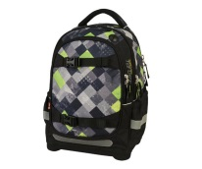 | _____________________
BABICA |  | _______________________
 |  | _______________________

