Dragi tretješolec!

Spodaj na linku najdeš zanimive vaje, ki ti bodo popestrile urice matematike Veselo reševanje ti želim!

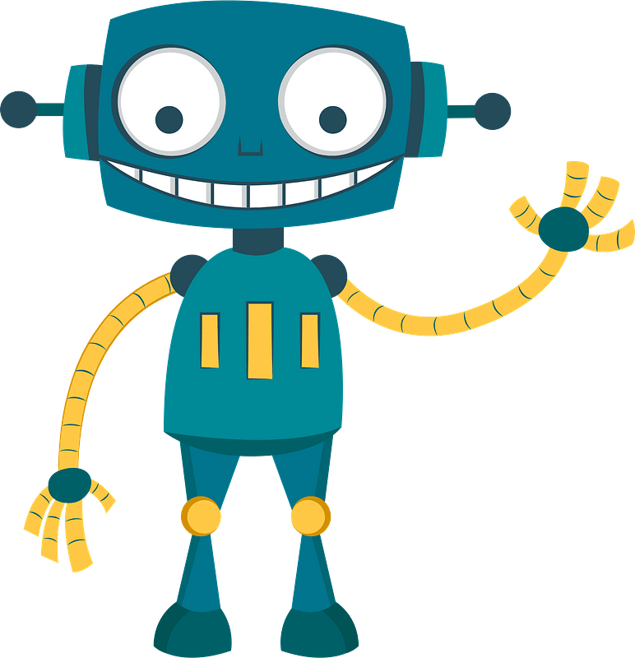

https://nasaulica.si/puzzles/player/641/967?prev=starsi&page=1

https://nasaulica.si/puzzles/player/640/1040?prev=starsi&page=1

https://nasaulica.si/puzzles/player/363/965?prev=starsi&page=1

https://nasaulica.si/puzzles/player/641/967?prev=ucitelji&page=1

