Tuesday, 1 December:
Hello!

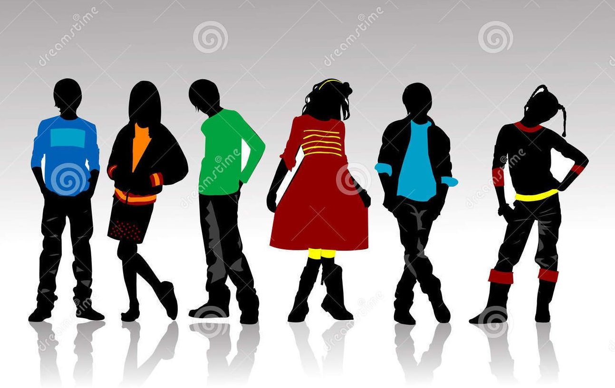

1. Odpri učbenik na strani 27, naloga 12 AT THE FASHION SHOW (Na modni reviji). Še enkrat poslušaj posnetek At the fashion show, ki se nahaja v današnji mapi v spletni učilnici, in ugotovi, kdo je kdo.
Nato v zvezek napiši naslov At the fashion show in zapiši, kaj imajo manekeni oblečeno.
Dodaj še pohvale za oblačila, npr. very pretty, lovely, cool, fantastic, I love it…
Primer: Sammy is wearing a cool yellow t-shirt, white shorts, yellow socks and lovely yellow tennis shoes.
Zapiši še za ostale:
Adam is wearing …
Linda …
Ruth …
Jill ..
Zapiši še zase, kaj imaš zdaj oblečeno, in nato še za mamo/očeta/sestro/brata/prijatelja/prijateljico:
I am wearing …
My mother/father/sister/brother/friend is wearing …

2. Prepiši v zvezek:

What are you wearing?
Tako povemo, kaj imamo oblečeno zdaj, v tem trenutku, danes:
What are you wearing? Kaj imaš oblečeno (zdaj, v tem trenutku)?
I am wearing a sweater and jeans.
What is she wearing? Kaj ima ona oblečeno?
She is wearing a red polka dot dress.
What is he wearing? Kaj ima on oblečeno?
He is wearing a pullover, trousers, a jacket and boots.
What are they wearing ? Kaj imajo oni oblečeno?
They are wearing t-shirts, shorts and trainers.
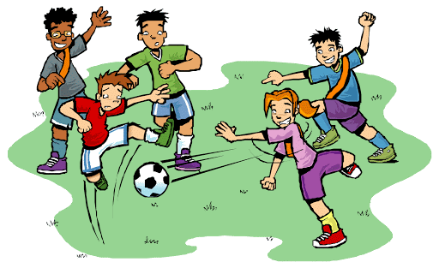

3. Za vajo reši nalogo 33 na strani 36 v delovnem zvezku.

Za konec si poglej še video posnetek.
https://www.youtube.com/watch?v=6QgVd4UBsvU
 Ko pogledaš video posnetek, odgovori na naslednja vprašanja (ustno):
- Why is there a mess in his room?
- What is Steve looking for?
- Why does Steve need warm clothes?
- It's cold and snowing today. What is Steve wearing?

Well done!

