Friday, 11 December 2020:

Hello!
Preden začneš, preglej včerajšnje naloge iz delovnega zvezka. Rešitve so na koncu teh navodil.
Najprej ponovi dialoge v trgovini z oblačili:
1. Reši naslednjo interaktivno vajo, tako da poslušaš in zapišeš cene. V 2. nalogi pa še dopiši yes, če je kupec kupil oblačilo, ali no, če ga ni kupil: https://www.liveworksheets.com/ry607165fy
2. Nato reši še to interaktivno nalogo - dialog postavi v pravi vrstni red. Ko končaš, klikni FINISH in CHECK MY ANSWERS, da preveriš rešitve: https://www.liveworksheets.com/vj594491hn

Danes se bomo učili o športih in oblačilih
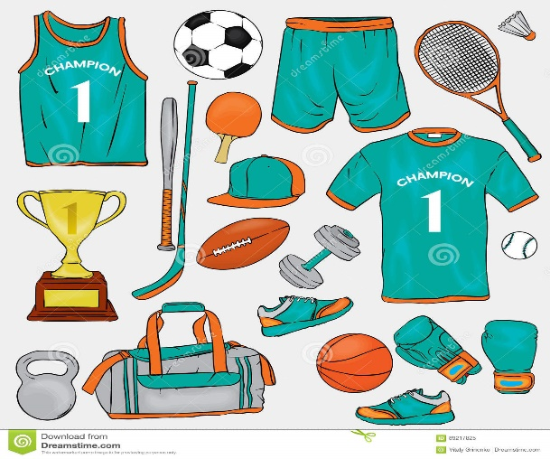
3. Odpri učbenik na strani 32, naloga 23. Poslušaj posnetek Our football team, ki je v današnji mapi v spletni učilnici. Med poslušanjem beri besedili ter ugotovi, katere besede manjkajo. Nato v zvezek zapiši naslov Our football team in prepiši dopolnjeni besedili iz bele in rumene majice v zvezek.
4. Zdaj pa pojdi na stran 33 v učbeniku in si oglej slike v nalogi 27. Kaj imajo osebe oblečeno? Povej po angleško: He is wearing … She is wearing …
Nato poslušaj posnetek Sports and clothing in v zvezek zapiši za vsako sličico: številko, ime in kaj ima oblečeno.
4. Za konec naredi še naslednjo interaktivno nalogo. Preberi opise oseb in ugotovi, kdo je kdo. Zapiši imena nad sličice. https://www.liveworksheets.com/no122vf
Se vidimo v sredo – ne pozabi: 5 min prej, da si pogledamo še vstop v spletne učilnice!

Rešitve nalog v delovnem zvezku:
Naloga 27: Max wants to buy a new T-shirt. He walks into the store and looks for T-shirts. There are many nice Tshirts of different colours. He wants a black T-shirt so he looks for it. When he finds it he takes it to the dressing room. He tries the black T-shirt on. It fits him and he likes it very much. He takes it off and he goes with it to the cashier. He buys it and takes it home. He is very happy with his new T-shirt.
Naloga 29: How much is this hat? It's €15 (fifteen). How much is this blouse? It's €35 (thirty-five). How much are these shirts? They're €38 (thirty-eight). How much is this blouse? It's €50 (fifty). How much is this dress? It's €88 (eighty-eight). How much are these shoes? They're €75 (seventy-five). How much is this sweater? It's €89 (eighty-nine). How much are these jeans? They're €100 (hundred).
Naloga 30a: 3, 1, 2

