WORKSHEET: FUNGI

NAME AND SURNAME:______________________

- Where do fungi grow?_____________________________________________________
_________________________________________________________________________

- Look at three different mushrooms. Sketch and label them.
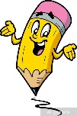

- Fill in!

Because fungi do not have green pigment or _____________ they, unlike plants, cannot use photosynthesis to get food. In order to survive, fungi need organic matter of other organisms. Such organisms are called HETEROTHROPIC ORGANISMS.

- Plants have cellulose in their cell wall. What is the name of the substance that fungi have in their cell wall?
____________________________________________________________________
(This substance is also present in the outer shell of crabs and insects.)

- In a cup carefully mix 5 small spoons of flour, 1 teaspoon of sugar, a piece of yeast, add a bit of lukewarm water and mix. Cover the cup with paper and put it in a warm place for 10-15 minutes.

What happened? Can you explain these events? What is yeast? Can you link this with baking bread?

- Mix a piece of yeast with warm water. Leave it where it is warm for 10 minutes then take a drop of the solution, make a fresh preparation, and observe it under the microscope. Draw a sketch of it.

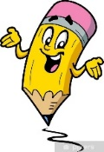

- Fill in the chart.

FUNGUS | WHAT IT FEEDS ON | DRAW A SKETCH
Saprophyte
Parasitic fungus
Mycorrhiza fungus

- What is the significance of fungi in nature?
______________________________________________________________________________________________________________________________________

- What is the significance of fungi for people?
______________________________________________________________________________________________________________________________________

- Moulds are also fungi. The most famous mould is Penicillium sp. which they use to make penicillin antibiotic. Take a piece of mould, make a preparation and look at it under the microscope. Draw a sketch of what you see.

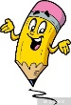

- Where have you seen moulds? What types of moulds are they? Do you know of any other uses of moulds? _______________________________________________________________________________________________________________________________________________

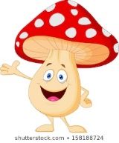
Did you know that...
- they used to use milk poisoned with fly agaric to poison flies.
- the English call the Coprinus comatus the lawyer's wig. When it is young it is edible and delicious.
- the giant puffball, which shoots its spores in the air, can weigh up to 25 kg and grow
25 cm high.
- the death cap is the most poisonous mushroom in Slovenia and Central Europe.

