the ecological footprint

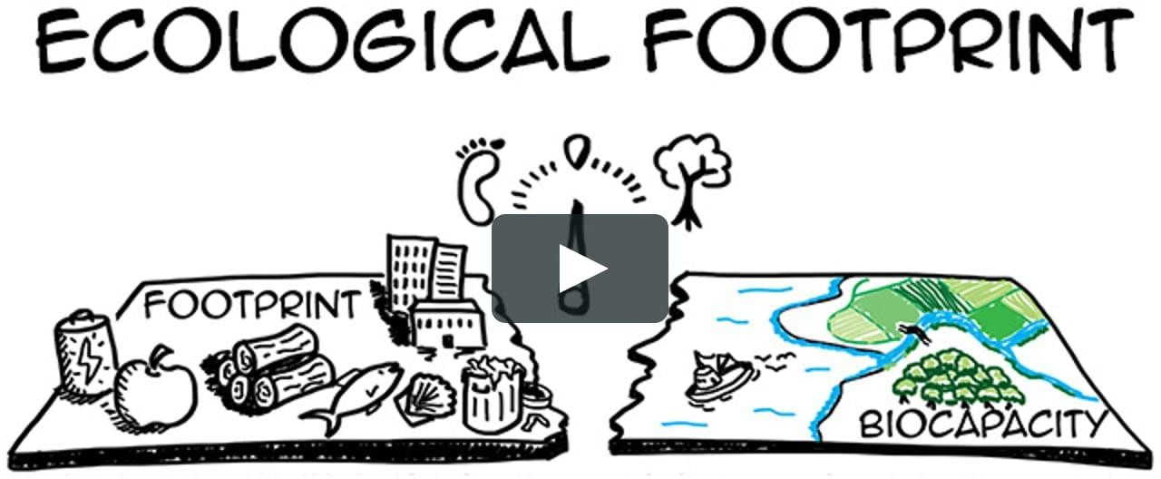

Secondary school lower level (middle school) IC FALCONE BORSELLINO BARDOLINO ITALY
CLASS IIID
EE: ECOLOGY, ECOLOGICAL AWARNESS ECOSUSTAINABILITY AND ECOLOGICAL FOOTPRINT
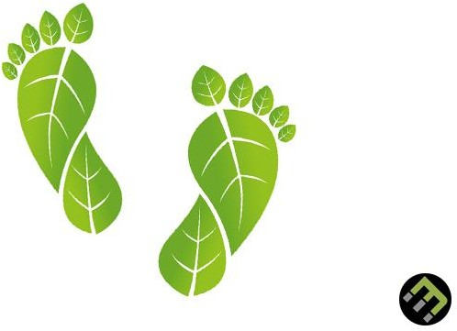

INSPIRING ACTIVITIES
We suggest pupils to calculate their personal ecological footprint, it is possible to do it through a online tool, a software in which the student fills out a questionnaire: the site
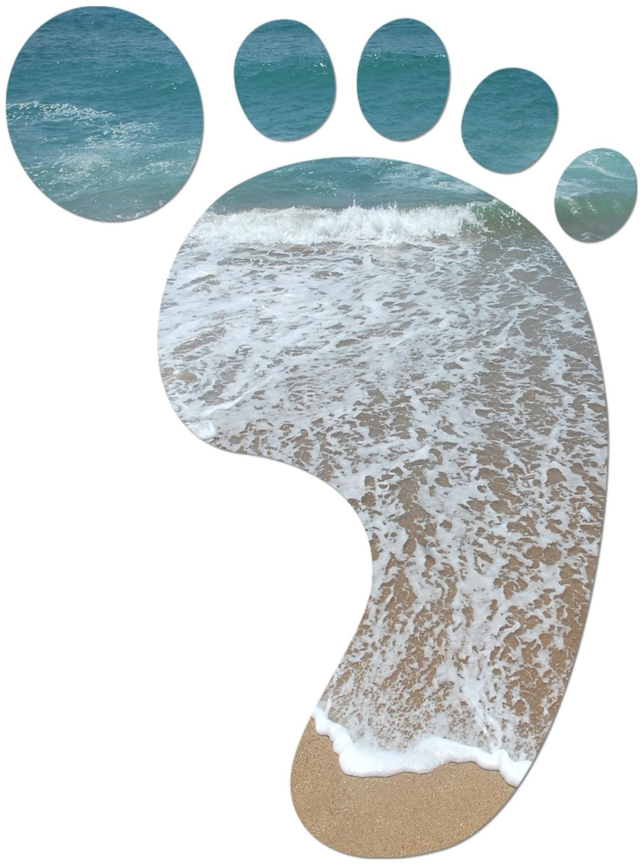
http://www.wwf.ch/it/

is an example.

Based on the daily adopted lifestyle (nutrition, transports,

usual energy consumption..), the software returns two kind of information:
1) the calculation of the portion of planet surface that we “consume”, 2) the calculation of how many planets would be needed to support humanity if all Earth inhabitants adopted this same lifestyle.

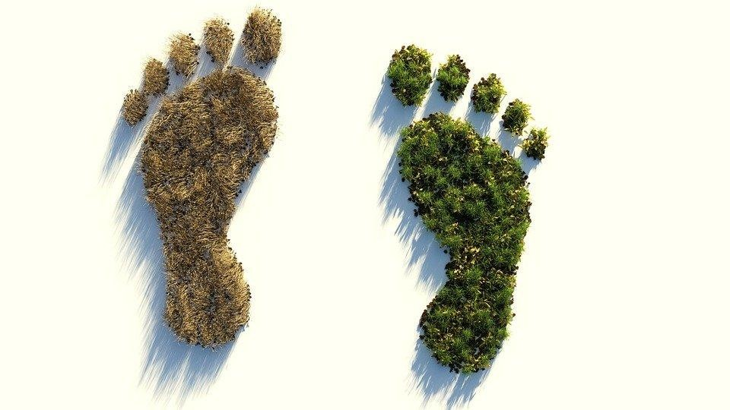

Pupils are generally shocked to learn that to support the

lifestyle of a boy, who goes to the park by bicycle, we would need 5 planets Earth!
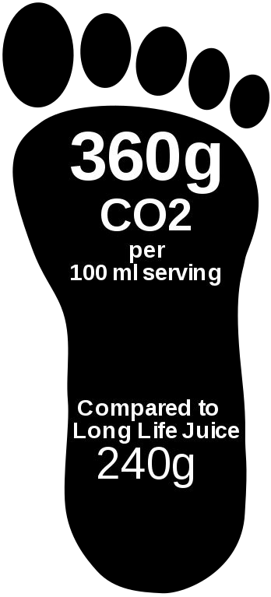
This leads them first of all to want to understand what the factors are, that make their style so expensive for the planet and secondly it will facilitate them in the task of making them reflect on the concept of eco-sustainability.

BEFORE THE LESSON

Before addressing the subject, some foreknowledge are needed, in particular the concept of ecosystem and its balance; knowledge of the cycles of status and circles of matter ( materials) and of food-nets.
With the students,we will deal with the concept of ecological footprint, we will calculate theirs personal and we will reflect on what are the factors that make the planet suffer and their so “expensive” lifestyle: we will collect ideas and put them back in the notebook.
They will understand which are the most impacting habits.

Activity in the class

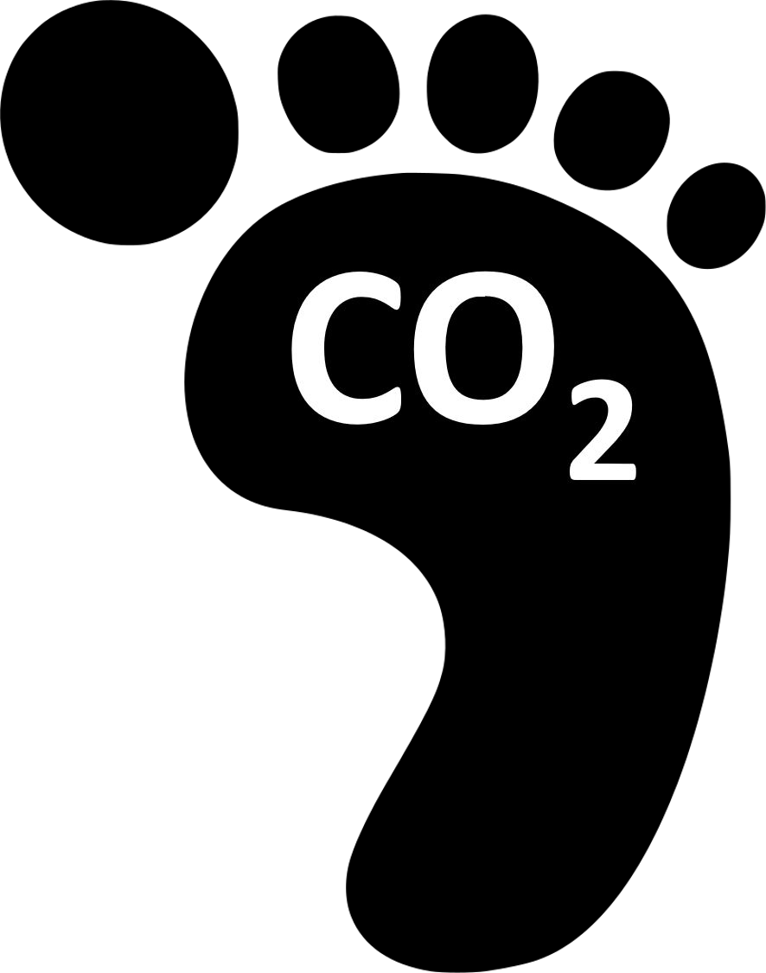
In the classroom a discussion is started, on what emerged from the work done at home and, through a short brainstorming, the considerations of pupils are collected to finally propose, to calculate an average ecological footprint of the class.

Students will be asked to develop a list of possible strategies / interventions to be adopted for
reduce the calculated ecological footprint, that is, to make our lifestyle more eco-sustainable!
The work will be collected in an explanatory drawing , a map or a short video.

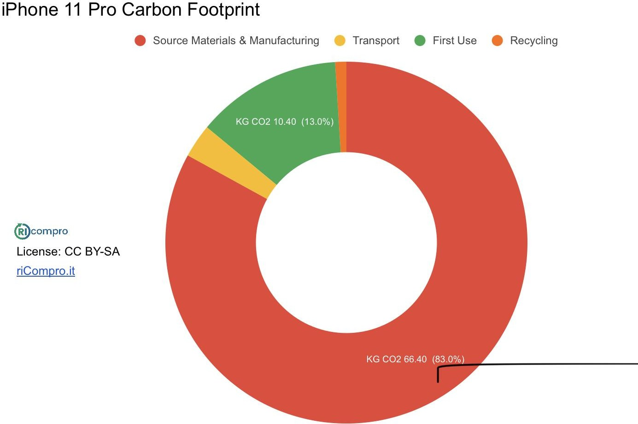

Activities to conclude the teaching/ learning activity and evaluate:

The evaluation of the product will represent a first formative check, which will take into account various factors included in an evaluation grid (creativity, punctuality, participation...)



Subsequently, a summative test in the form of an authentic problem will be given as a proof of real task: students will be asked to imagine a typical day, which inserted in the online questionnaire used at the beginning of the activity returns an ecological footprint equal to 1 planet Earth or less, that is, perfectly sustainable

Prof Alessandro Todaro, Science Teacher Professoressa Hilda Forte, class Teacher Professoressa Elena Maccari, Erasmus+coordinator and translator



