3. pisni preizkus znanja, angleščina kot drugi tuji jezik GFML
1. letnik, program gimnazija

I Read the tet carefully. Answer the questions according to the text. 8P
Pozorno preberi besedilo in odgovori v celih povedih, glede na besedilo.
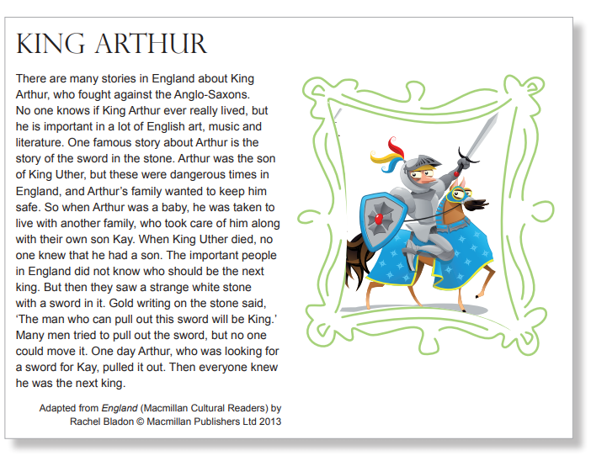

- Did King Arthur really live?
- Who was Arthur´s father?
- What did they do with Arthur when he was a baby?
- Who was Kay?
- What did the important people not know?
- What did the people see?
- Who could be king?
- What did many men try?

II Complete the text with the given words. 8P
Dopolni besedilo z danimi besedami.
brought 1588 virgin father second a girl sister monarchs

The daughter of Henry VIII and his ……………….. wife, Anne Boleyn, Elizabeth I (1533–1603) was England’s ‘Gloriana’ – a ……………….. queen who saw herself as wedded to her country and who ……………. almost half a century of stability after the turmoil of her siblings’ short reigns.
Red-haired, white-faced and always lavishly dressed, Elizabeth possessed the natural charisma of her …………….. , Henry VIII, and was the darling of her people. Her finest hour came in …………. when she defeated the Spanish Armada, catapulting her to legendary status.
Although Elizabeth is now known as one of our greatest ………….., she should never have got anywhere near the throne. She was ………………. at a time when the laws of said a king can be only a boy, but she had an elder ……………., Mary. Elizabeth was also removed from the line of succession altogether when her parents’ marriage was declared invalid prior to Anne Boleyn’s execution, and was only reinstated thanks to the kindly intervention of her last stepmother, Katherine Parr.

III Form sentences in the PAST SIMPLE 8P
Tvori povedi v navadnem pretekliku (pazi, glagol ni spregan!)
A – She/ study/ in/ France/ and/ go / to University/ there
____________________________________________________________________
B – Da Vinci/ be / a genius/ and/design / many buildings
____________________________________________________________________
C – Maria Curie /get / two Nobel Prizes/ in 1903 and 1911
____________________________________________________________________
D – Walter Raleight/ introduce/ potatoes and tobacco/ to Europe?
____________________________________________________________________
E- Elizabeth I / not sail/ around the world
___________________________________________________________________
F – Bodiecea´s husband/die/ but/ Roman soldiers/ not beat/ Bodicea.
___________________________________________________________________
G- You/ see/ the Loch Ness Monster?
____________________________________________________________________
H- They/ stay/ at a farm/ and/ not have/ a camera
____________________________________________________________________

IV Present Simple or Pat Simple? 6P
Navadni sedanjik ali navadni preteklik?
1 – She ______(leave) the office one hour ago and _____________(not do) her work.
2 – The computer EPICAC ______________________(write) many poems and then it ____________(destroy) itself.
3 – People think these large cats ______________________(be) pets of rich people.
4 - _________ you ever __________________(play) computer games based on stories?
5 - _____________your friend __________________________(like) science fiction?
6- The Nobles ________________(rebel) against Mary and then they ________(put) her into prison. She was executed in 1587.

Ime in priimek:
Točkovnik:
odlično | Prav dobro | dobro | zadostno
30- 27 | 26- 23 | 22-19 | 15-18

