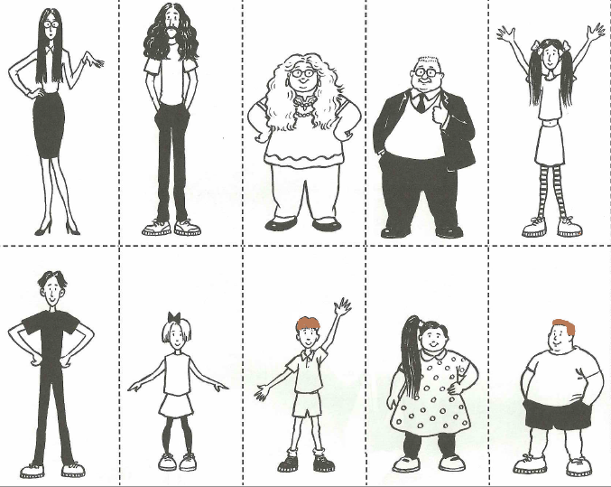
10
9
8
7
6
5
4
3
1
2
Describe people (opiši ljudi).
Use the following expressions: (Uporabi naslednje izraze):

She's/He's a man (woman/boy/girl).
He's / She's tall /short and thin/overweight.
He's got /She's got short /long
black/brown/blonde hair.

