ANGLEŠČINA 5. razred  PON (3. 5. 2021) | 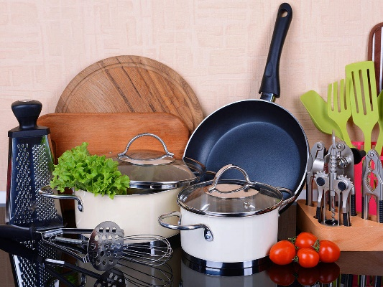
KITCHEN THINGS

Open your student book on page 72, exercise 21 (odpri učbenk na strani 72, naloga 21.) Look at the picture with kitchen things. Match the words with the pictures. (Poveži besede s sličicami).
After you finish, check with the following translations (Ko končaš, poglej prevode spodaj in preveri, če si pravilno povezal/a):

spoon – žlica pan – ponev fork – vilice bowl – skleda teaspoon – čajna žlička
plate – krožnik knife – nož pot – lonec glass – kozarec cup – skodelica

1. Write the title KITCHEN THINGS in your notebook. (V zvezek napiši naslov KITCHEN THINGS – kuhinjski predmeti.)
Copy the words from SB page 72, exercise 21, in your notebook and draw the pictures next to them (V zvezek prepiši besede iz strani 72, naloga 21 v učbeniku in poleg besed nariši sličice kuhinjskih predmetov).

2. Open the handout Things we find in every kitchen (Odpri učni list Things we find in every kitchen). Match the words with the pictures. If there are any words you don't know, look at the second page for translations (Poveži besede s sličicami – ustno, ni treba natisniti učnega lista. Če katere besede ne poznaš, poglej na drugo stran, kjer so prevodi.). Copy new words and translations in your notebook (nove besede iz učnega lista prepiši v zvezek skupaj s prevodi)

3. Open your workbook and do exercises 15 and 16 on page 69. (Naredi vaji 15 in 16 na strani 69 v delovnem zvezku).
Enjoy your afternoon and see you tomorrow!

