PREVERJANJE ZNANJA IZ ANGLEŠKEGA JEZIKA – NIP (1. leto učenja)

1. Poslušaj in na črto napiši številke.

______ ______ ______ ______ ______ ______ ______ ______ ______ ______

2. Zapiši števila z besedo ali številko.

ten ___________ 7 __________________
two ___________ 16__________________
fifteen _________ 1___________________
twenty ________ 9___________________
eleven ________ 12__________________
1 Hello! | _____ It's a book!
2 What's your name? | _____ I'm Greg!
3 What's this? | _____ It’s red.
4 What's colour is a bike? | _____ It’s Jack.
5. Where do you live? | _____ Hi!
6. Do you like pizza? | _____ Yes, I do.
7. Who’s this? | _____ I live in Ljutomer.

3. Preberi in poveži. Na desno vpiši ustrezno številko.

4. Prevedi besede. (Pomagaj si s črkami v okvirčkih.)

jabolko an ________________ (PAPEL) ženska a ______________
pomaranča an _______________ (ROGAEN) (AWMON)
sladoled an ___________________ (CRICEMEA) dojenček a _____________
zrezek __________________ (KTSEA) (BYBA)
tovornjak a _________________ (ROLRY) letalo a _____________
svinčnik a ___________________ (CINPEL) (LAPNE)
vlak a ____________________ (NATRI) žoga a _______________
punčka a ___________________ (LODL) (LABL)
ravnilo a ____________________ (LERUR) fant a ________________
radirka a ___________________ (ERBUBR) (YOB)

5. Kje sta Flossy in Otto? Poglej slike in dopolni povedi z ustreznim predlogom.
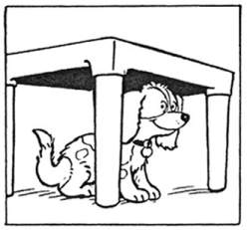
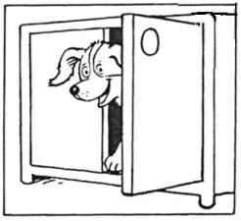
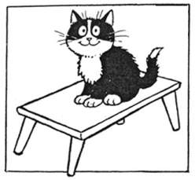

Flossy is _______ the cupboard. Flossy is ________ the table. Otto is _______ the table.

6) V okvirčke vpiši ustrezne besede.

arm hand nose eye hair ear knee leg toes foot fingers mouth neck

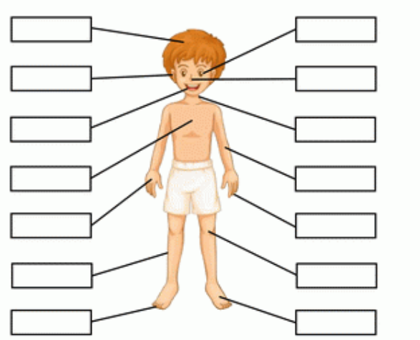
chest

9. Opiši sebe in svojega najboljšega prijatelja. (Vključi podatke: ime, velikost, postava, barva oči in las.) Pomoč: My best friend is …..
________________________________________________________________________________________________________________________________________________________________________________________________________________________________________________________________________________________________________________________________
________________________________________________________________________________________________________________________________________________________________

