VARNOST V PROMETU

1. Kaj je načrt šolskih poti?
________________________________________________________________________________________________________________________________________________________________________________________________________________________________________________________________________________________________________________________________________

2. Kaj je prometno-varnostni načrt šole in zakaj je pomemben?
________________________________________________________________________________________________________________________________________________________________________________________________________________________________________________________________________________________________________________________________________

3. Naštej vozila, ki imajo prednost in jim rečemo prednostna vozila?
______________________________________________________________________________________________________________________________________________________________________________________________________________________________________________________

4. Kje hodimo po pločniku:
- če smo sami?
__________________________________________________________________________________
- če hodimo v spremstvu odraslih?
____________________________________________________________________________________________________________________________________________________________________
5. Kako hodimo po cesti, kjer ni pločnika?
____________________________________________________________________________________________________________________________________________________________________

6. Kako pravilno prečkaš cesto?
______________________________________________________________________________________________________________________________________________________________________________________________________________________________________________________
7. Naštej obvezno opremo kolesa?

__________________________________________________________________________________

__________________________________________________________________________________

__________________________________________________________________________________

8. V spodnji prostor skiciraj kolesarsko čelado in napiši, kako je sestavljena.

9. Kako pravilno uporabljamo čelado?
__________________________________________________________________________________
10. Poimenuj zanke.
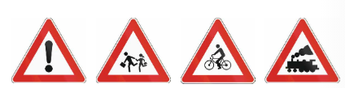
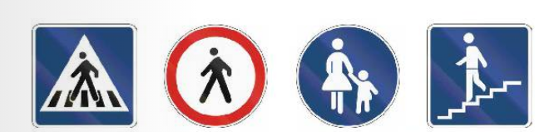
11. Zapiši sestavne dele kolesa.
