- Form sentences for given animals (CAN / CAN'T).
A WHALE / √ swim /X jump A whale can swim but it can't jump.
PARROTS /√ speak / X run fast Parrots can speak but they can't run fast.

A FOX/ √ dig holes / X fly
______________________________________________________
AN OSTRICH /√ _____________ / X fly
______________________________________________________
A HIPPO / √ swim / X _______________
______________________________________________________
ZEBRAS / √ gallop / X climb trees
______________________________________________________
A LION / √ roar / X _________________
______________________________________________________
A SNAKE / √_______________ / X run
______________________________________________________
A KOALA / √ climb trees / X speak
______________________________________________________
HENS / √ lay eggs / X _______________
______________________________________________________

- Answer the questions.
What can a crocodile do? ___________________________________
Can an ostrich fly? ________________________________________
What are pigs like? _______________________________________
Are snakes dangerous? ____________________________________

- Fill in the missing words (information).
A zebra lives in Af __ __ __ __ and in a ZOO. A zebra likes/eats _______________ but it ____________ like meat.
A zebra can ___________ but it _________ jump from tree to tree.
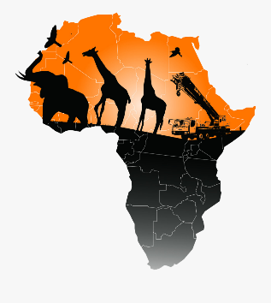
A zebra is _________and__________ (colour) and it is ________________.

