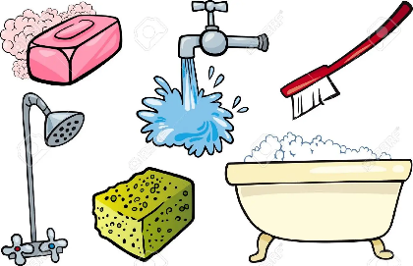
UMIVANJE ZOB JE POMEMBNO ZATO, KER ______________________________________________________
______________________________________________________.
NOŠENJE ČISTIH OBLAČIL JE POMEMBNO ZATO, KER ______________________________________________________________________________________________________________________________________________________.
VSAK DAN SE TUŠIRAM ZATO, KER ______________________________________________________________________________________________________________________________________________________.
KO IMAM UMAZANE ROKE, SI JIH UMIJEM ZATO, KER ______________________________________________________________________________________________________________________________________________________.
UMIVANJE LAS JE POMEMBNO ZATO, KER ______________________________________________________________________________________________________________________________________________________.
KO KIHNEM UPORABIM ROBČEK ZATO, KER ______________________________________________________________________________________________________________________________________________________.

