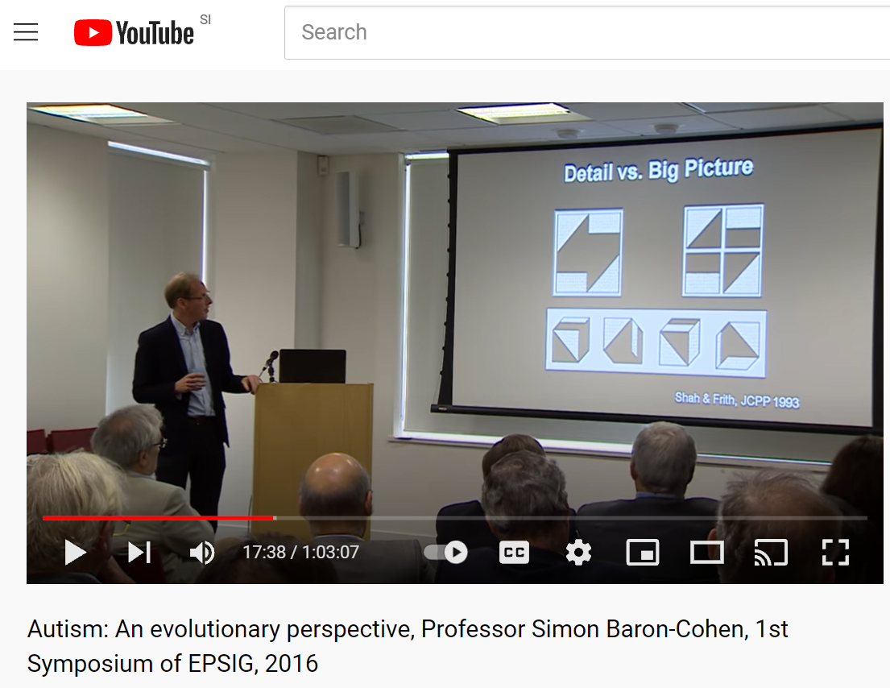
Povezava: Autism: An evolutionary perspective, Professor Simon Baron-Cohen, 1st Symposium of EPSIG, 2016 - YouTube

